

MA International Fashion Marketing
Nostalgia Marketing in Fashion
Analysing the effectivity of nostalgia marketing and how it influences fashion consumers response.

Date: May 13th 2022
Name: Sam Sadek
Student ID: S00907812
Supervisor: Chris Pickford

Chapter 1: Introduction
1.1 Introduction

Nostalgia itself has been proven to elicit positive feelings within the individual experiencing it (Wildschut et al., 2006). When applied to marketing, nostalgia was shown to have the same effect (Ju et al., 2016; Chou and Lien, 2010). People feeling nostalgic tend to purchase nostalgic products (Lasaleta et al., 2014). The nostalgia effect on the consumer prompts their positive reactions towards the showcased marketing strategies (Ju et al., 2016; Chou and Lien, 2010). Fundamentally, the effectivity of nostalgia marketing lies within its psychological influences (Wildschut et al., 2006). The nostalgia marketing phenomenon is fundamentally about communicating a brand or product to the audience by utilising nostalgic cues that can help trigger feelings of nostalgia within the viewer (Ju et al., 2016). This sense of nostalgia is what triggers the consumers positive responses towards what is being presented to them. In fashion, nostalgia marketing has proven to be effective (J et al., 2021). Today, nostalgia marketing strategies in fashion are heavily witnessed on social media. In fact, fashion-based nostalgia advertisements in social media have been shown to improve consumer attitude towards the advertisement as well as the brand and their purchase intentions (Youn and Jin, 2017). Several factors contribute to this. These factors include the increase of focus on the Gen Z consumer and their affinity towards nostalgic trends (Hoffower, 2022). As trends have been shown to influence demand (Vogt, 2017), marketing strategies can subsequently mirror this change in demand (The Economist, 2018).
Additionally, the fashion trend-cycles have been on an accelerated path (Mollard, 2022; Cochrane, 2022). Some have attributed this rise to the acceleration of nostalgia (Cochrane, 2022). This has created more space for nostalgia marketing strategies to flourish as the nostalgic trends have been on a consistent rise (Trendalytics, 2021; Hoffower, 2022). Many fashion brands have made use of this strategy in order to communicate their product to the nostalgic consumer and many have succeeded in doing so (Pauly, 2021). The literature review chapter of this research will detail the psychology behind nostalgia and will also identify the factors that influence the effectivity of nostalgia marketing strategies. The research will also identify and analyse the factors contributing to the current rise in usage of nostalgia marketing strategies. Moreover, the research will also identify the factors that influence the current usage of marketing strategies in the fashion industry today. Finally, the researcher will be conducting interviews in order to analyse and identify the effects of fashion-based marketing strategies on fashion consumers.

1.2 Aim and Objectives

The aim of this research is to analyse the effectivity of nostalgia marketing strategies on fashion consumers.

- Analyse the psychology behind nostalgia
- Identify and analyse the factors that play a role in the effectivity of nostalgia marketing.
- Identify the factors that contribute to the rise in usage of nostalgia marketing strategies.
- Identify the factors that contribute to the usage of nostalgia marketing strategies in fashion.
- Identify and analyse the effect of fashion-based nostalgia marketing strategies on fashion consumer.

1.3 Secondary Research Approach

Secondary research will be conducted in order to find relevant data on the topic as well as form links and comparisons. Secondary research consists of published data that hasn’t been conducted and gathered by the individual devising the research (Bouchrika, 2021). The secondary data that was found for this research includes several studies conducted on various topics relating to this research as well as information relevant to this research that have been gathered by other researchers. The researcher will compare various findings to one another in order to find links and patterns between varying sources and studies. Comparative analysis is utilised in order to find differences and commonalities between two or more sets of data and findings (Simister and Scholz, 2017). In literature reviews, a comparative analysis is conducted by examining possible differences and similarities between different literatures (Onwuegbuzie and Weinbaum, 2017). This will allow the researcher to formulate a general consensus on the topic being discuss by comparing and contrasting different findings related to the topic. Subsequently, the researcher also related the themes formulated through the comparative analysis in the secondary research to results found through the primary research.

Chapter 2: Literature Review

2.1 The Psychology Behind Nostalgia

Nostalgia was once considered as a sign of insecurity and was deemed a hindrance to modern progression (Jamali, 2012). In 1985, Roderick Peters, a psychoanalytic theorist, believed nostalgia in the most extreme form to be a debilitative force and explained how it can interfere with coping during present circumstances (Batcho, 2017). More recent studies have described nostalgia as a stabilizing force that can help strengthen personal identity through uniquely reminisced memories that remind individuals of their core beliefs (Batcho, 2013). Concurrently, the sense of nostalgia became closely linked to the progression and understanding of modern consumer culture (Havlena and Holak, 1991).
Music Journalist, Simon Reynolds, has described this phenomenon as “pop culture’s addiction to its own past” referring to it as “Retromania” (Harvey, 2011).

Author and behavioural psychologist Carolyn Mair has stated that one of life’s biggest stressors is the feeling of lack of control. She explains that this feeling is what prompts us to focus on what we can control, our memories of the past. Mair has also stated that society associates nostalgia with past feelings and experiences projected in a positive light, making us want to re-inhabit those feelings during harder times (Montgomery, 2020). Moreover, further research has shown that shown the significance of nostalgia and its positive effect on negative feelings (Wildschut et al., 2006).

Nostalgia can be triggered by sensory stimuli as well as conversation or simple memory recollection (Moawad, 2016). Additionally, nostalgia can be classified as a form of escapism (Wulf et al., 2021). Escapism is the regular distraction of the mind to a more imaginative activity as an escape from reality. Escapism can be classified as either functional or dysfunctional (Wulf et al.,2021). Functional escapism is ones need to indulge themselves in enjoyable and evocative subjects. Dysfunctional escapism is a form of escape from one’s problems. Indulging in nostalgic media can be a form of either functional or dysfunctional escapism, depending on the way it is approached by the individual.
Several researchers have indicated two types of nostalgic feelings, historical and personal nostalgia (Stern, 1992; Marchegiani and Phau, 2010). Historical nostalgia refers to feeling nostalgic for a time before one’s own. Personal nostalgia is feeling nostalgic towards a certain a time or memory that has been experienced by the individual.

In regard to the causes of nostalgia, Dr. Krystine Batcho, licensed psychologist and professor of psychology at LeMoyne College, states that unhappiness with current situations or realities can serve as a significant cause for nostalgia (Batcho, 2019). The younger generation are possibly more historically nostalgic. According to Dr Batcho, the feeling of dissatisfaction with present reality will prompt them to believe that things in the past must have been better (Batcho, 2019).

Millennials are widely considered to be one of the most nostalgic generations. Cassandra Mcintosh, Senior Insights Analyst at Exponential, has mentioned that “Millennials are coming of age in an age of economic turmoil – a difficult job market,”. Mcintosh attributes this as the reason why millennials resort to reminiscing about simpler times (Dua, 2015).
In addition to Carolyn Mair, Generational expert Alexis Abramson has also pointed out the association of positive feelings with nostalgia and focuses on millennial consumers and their fond appreciation of the past (Abramson, 2019). Abramson states that millennials “want more of the same” when it comes to past memories of fashion or pop culture and mentions that the millennial ability to nurture these nostalgic feelings is due to the accessibility of these memories within social media and the internet. Tim Wildschut, an Associate Professor of Psychology at the University of Southampton, has mentioned that nostalgia can become more embedded in our culture due to the overload of information that is present throughout social media that can help trigger feelings of nostalgia. He has also stated that nostalgia is on the rise because of the accessibility of social media (Wildschut, 2016).

When looking into the fashion trends of millennials, Alexis Abramson has stated that there is a certain lack of creativity and imagination. Abramson explains that this lack of imagination is due to the millennial’s substantial reliance on their past memories (Abramson, 2019). Additionally, Abramson mentions that the newest generational study shows that millennials are more “risk averse” and contributes this as one of the reasons why this generation tends to set less fashion trends (Abramson, 2019). In contrast, research has shown that creativity is subjective and based on unique views (Boden, 1997, Slappendel, 1996). Ananya Kumar, Fashion designer and author at Entrepreneur India, has stated that millennials are experimentational with their creative practices. Kumar also states the importance of inspiration from past experiences and believes these experiences and unique stories can help elevate individuality (Kumar, 2019).

Gen Z are considered to be more prone to depression and loneliness than other generations. This prompts them to be more inclined to indulge in nostalgic subjects in order to ease any negative and nervous feelings (Pankowski, 2022). As Dr Batch states, being dissatisfied with present reality can prompt us to want to re-experience the past or want to experience an era we might not have been physically present in, in the form of historic nostalgia. This is evident with Gen Z as they have shown keen interest in Y2K fashion and the revival of this trend can be attributed to their desire of inhabiting it (Hoffower, 2022). Michael Pankowski, founder of Crimson Connection, states that the pandemic has had a severe effect on one-to-one exchanges leaving us with an almost entirely digital existence. Due to the effects of the pandemic Gen Z had a hard time adjusting to the work force and finding jobs (Hoffower, 2020). Gen Z were the most affected generation in the work force. Many, upon their graduation were faced with a distorted sense of reality during a very pivotal moment of their lives. As a coping mechanism, Gen Z opted to reminisce on times where social media did not exist, the 90’s and early 2000’s. Ironically, these nostalgic connections were made on social media (Pankowski, 2022). This proves Dr Batcho’s and Carolyn Mair’s points on nostalgia being more relevant in an individual’s life during times of dissatisfaction and the pandemic having a grave effect on Gen Z gave them more of an incentive to embrace their nostalgic feelings.

Nostalgia is also linked to self-continuity. Self-continuity is a uniquely functioning type of autobiographical memory. It prompts individuals to have a vivid recollection of their past
selves. Subsequently, self-continuity plays a big role in understanding and forming one’s current identity through personal remembered experiences (Bluck and Alea, 2008). The link between nostalgia and self-continuity is well observed. Nostalgia can serve as a trigger for perceived self-continuity and help with maintaining and/or creating one’s current sense of identity (Sedikides et al., 2008).

2.2 Nostalgia Marketing

Nostalgia marketing is fundamentally about communicating a brand or product with a targeted audience using nostalgic measures that relate to a specific or generalized positive recollection of the past. Nostalgia marketing is essentially a form of experiential marketing (Ju et al., 2016). Experiential marketing is an approach to marketing, where the foundation of the advertisement is not solely based on the product but also based on cognitive, emotional and atmospheric elicitations (Schmitt, 2000). It comprises of touch points that are set in place in order to evoke emotional and psychological feelings to the intended audience. These touch points include sense, thought, action, feelings, and relating (Schmitt, 2000). Sense can be triggered through taste, smell, sight, sound and touch (Ju et al., 2016). Additionally, these touch points also help consumers respond to the advertised products through their perception of the way the product is being marketed. This is based on the individual viewers experience with the portrayed theme of the advertisement and is done by conjuring psychological connections with the audience. Nostalgia marketing is classified as a form of experiential marketing as it stimulates the viewers senses and also evokes emotions and feelings. Nostalgia marketing is also regarded as an important factor when looking through marketing research (Ju et al., 2016). Nostalgia can also be used when advertising products that are not considered nostalgic. The nostalgic measures are intentionally chosen in order to evoke nostalgia within the viewer (Muehling et al., 2014). Nostalgia intentionally invites the targeted audience to re-live past memories through various means. Nostalgic marketing strategies are suitable for both hedonic and utilitarian products. Hedonic products are products that are consumed in order to elicit positive feelings within the consumer (Hirschman and Holbrook, 1982). Utilitarian products are products that are consumed with rationale (Holbrook and Hirschmann, 1982). This can lead some to believe that nostalgia marketing should be more suitable and effective when advertising hedonic rather than utilitarian products since nostalgia marketing is related to more cognitive and emotional measures. However, studies have shown that neither outweigh one another in relevance to nostalgia marketing (Ju et al., 2016).

2.2.1 Authenticity
When brands utilize nostalgia marketing in a way that is authentically tailored, they are offering their consumers a brand experience that makes them feel good and in return their brand image is perceived more positively in the eyes of their target consumer (Oh et al., 2019) Additionally, nostalgic marketing techniques have proven to impact brand authenticity (Raza et al., 2020).

In a world where people are wearier of tactical and forced marketing techniques, authenticity has become the desired demand amongst consumers (Modicum, 2017). When brands produce marketing campaigns and advertisements that feel inauthentic to their consumers, the consumers tend to lose trust (Vizard, 2016). Nostalgia marketing, when done right, has an authentic touch to it (Heinberg and Katsikeas, 2019). This encourages consumers to gain trust in the brand as the nostalgic authenticity can be perceived through one, or more, of the mentioned touch points. The authentic feel that comes with nostalgia marketing can be considered as one of the aspects that makes nostalgia marketing an effective marketing strategy (Heinberg and Katsikeas, 2019).

2.3 Psychological Factors That Influence Consumer Response to Nostalgia Marketing.

2.3.1 Self-Continuity
As mentioned, the evocation of nostalgia can prompt one’s perception of self-continuity. Both self-continuity and nostalgia can elicit positive emotions within an individual. Moreover, nostalgia can help improve one’s psychological well-being by prompting the perception of self-continuity within an individual’s identity (Wildschut et al., 2006).

An analysis of a study conducted on the relationship between self-continuity and nostalgia marketing in 2016, comparing nostalgia marketing and marketing focused on present day content using both hedonic and utilitarian products, is necessary in order to understand the effectivity of nostalgia marketing when linking it to self-continuity. The study was based on two messages, one relating to present day and one that is more nostalgic. 199 participants took part in the study. The participants were divided into 2 groups reacting to each of the messages relating to two products. The hedonic product was fragrance, and the utilitarian was sunscreen. Attitudes towards the advertisement and the brand as well as purchase intent were all examined within the study. These points are considered to be pivotal factors and forecasters of consumer response (Brown and Stayman, 1992). Themes within advertisements have been proven to influence consumer attitudes towards a certain brand as well as their intent to purchase (MacKenzie et al., 1986).

The study successfully proved that the advertisements including nostalgic trigger points had a much more substantially positive effect on the participants attitude in response to the advertisement and brand as well as the nostalgic message in comparison to the present-day message. Additionally, the participants also showed more positive responses to the nostalgic advertisement in regard to their purchase intent. The study was also able to prove that sense of self-continuity had a greater impact as a result of the message found within the nostalgic advertisement in comparison to the present day focused one. Another point proven by the study was that the effects of the nostalgic messages do not outweigh one another in regard to the product type, meaning that the effects were the same for the hedonic as well as the utilitarian products (Ju et al., 2016). This study has showcased the increased perception of self-continuity when being exposed to nostalgic content in comparison to present-day focused content. This, subsequently, increases positive attitudes towards the advertisement (Ju et al., 2016). Another study on self-continuity and nostalgia marketing was conducted. This time, in order to examine the role self-continuity plays in a consumer’s decision-making process. 100 participants who participated in the previous study took part in the one being analysed. This time the product used was wine as it does not clearly fit into either a hedonic or utilitarian category and there was only one nostalgic message being examined (Ju et al., 2016). The study successfully proved the role self-continuity plays in purchase intent. The study also identifies how a consumer’s attitude towards a brand can facilitate the relationship between self-continuity and purchase intent as well as self-continuity and nostalgia (Ju et al., 2016).
These studies help identify the pivotal role self-continuity plays in nostalgia marketing. Research has indicated that self-continuity is evoked through nostalgia (Wildschut et al., 2006) and the studies above have proven how nostalgic content elicit a higher perception of self-continuity within the consumer when compared to a more current message. Additionally, self-continuity plays an even more significant role in nostalgia marketing as the study has shown that the relationship between self-continuity and purchase intent is high and purchase intent has been considered to be one of the most important factors of a marketing campaign as this intent to purchase can ultimately lead to an actual purchase. In other words, the intent is highly regarded to be an essential indicator of actualized behaviour (Montaño and Kasprzyk, 2015). Lastly, this study has proven the positive effect of nostalgia marketing in comparison to more current marketing messages which can lead to a preference of strategies with nostalgia marketing being the preferred strategy (Ju et al., 2016).

2.3.2 Music
Music is often used in marketing strategies as it appeals to many consumers and is regarded as one of the pivotal factors of an advertisement (Allan, 2006). Music also relates to sound which is one of the mentioned sensory touch points that is linked to nostalgia marketing. It has been mentioned that nostalgic sounds and lyrics as well as vocal prompts in advertisement can influence a consumer’s response and positive attitudes towards the advertisement (Muehling and Sprott, 2004).

Nostalgic music has been shown to have a positive effect on a consumer’s attitude towards the advertised product and brand (Williams and Faber, 1999; Petty et al., 1993). This is accomplished through the evocation of a consumer’s positive attitude and memories towards the nostalgic song itself, hence inducing the consumers good mood and positive attitude towards the advertisement as a result of the nostalgic triggers (Muehling and Sprott, 2004).

An analysis of a study conducted in 2010 on the effects nostalgic music and lyrics has on advertisements is necessary in order to further understand the role nostalgic music plays in the success of nostalgia marketing strategies. 276 Taiwanese undergraduate students participated in the study. The products being advertised were chocolate and a cookie bar. The commercials shown was the same for each product throughout the experiment. However, the songs being played as part of the advertisements were different with some being older nostalgic songs and the others being new and current songs. The study resulted in a higher rate of positive attitude towards the advertisements featuring the nostalgic music in comparison to the advertisements including newer songs. The study also resulted in a substantially positive effect on the mood of the participants and proved that evoking nostalgia related emotions and feelings considerably enhanced the participants attitude towards the advertisement (Chou and Lien, 2010). In regard to the participants attitude towards the brand, it was shown that the attitude towards the advertisement as a whole played a significant part in the participants positive response to the brand itself.
The study evidenced the significance of nostalgic music in advertising as the results from the study showed a substantial positive response towards the advertisements including nostalgic songs. The advertisements utilizing nostalgic songs also showed positive influence on the participants mood. This is crucial to the effectivity of nostalgia marketing as it has been evidenced throughout this case study as well as the one reviewed and analysed on nostalgia’s link to self-continuity that the evocation of a participant’s good mood and their positive responses as a result of the nostalgic content being shown played an integral role in the positive attitudes towards the brand and the advertisements used in the studies (Ju et al., 2016). Although the case study on nostalgic music in nostalgia marketing did not mention the effects on purchase intent, research has shown that a positive attitude towards a brand can positively influence purchase intent (Kumar and Kaushal, 2017) so the probability of purchase intent being higher due to the effects of nostalgic music in advertisements can be expected as attitudes towards the brand were shown to be positive throughout the study.
The elicitations of the participants good mood in both studies as a result of the nostalgic contents shown can also serve as a testament to the points made by Dr Batcho, Carolyn Mair and Alexis Abramson. Dr Batcho stated that nostalgia can be most felt when individuals are experiencing negative feelings or dissatisfaction with the present and Carolyn Mair and Alexis Abramson both pointed out the association of positive feelings triggered by nostalgia. The participants might not necessarily be experiencing negative emotions or dissatisfaction, but nostalgia being closely linked with helping improve or trigger the individual’s positive mood and outlook is aligned with the fact that the participants from both studies reacted more positively to the nostalgic content and their moods mirrored the statements on the positive effects of nostalgia since the positive reactions were showcased throughout. Another point that can be also considered as a reason for the evocation of good moods in response to the study on nostalgic music is self-continuity. As mentioned, self-continuity is understanding ones current self-based on past memories and experiences (Bluck and Alea, 2008). Subsequently, the nostalgic music being played can also heighten the participants perception of their self-continuity which in return can trigger their positive attitudes and good moods.

2.3.4 Para-Social Relationships
Another factor that can add to the effectivity of nostalgia marketing are para-social relationships. Para-social relationships are typically one-sided relationships that are developed by individuals and are usually directed towards a well-known personality (Vinney, 2021). This one-sided bond is typically a long lasting one almost mirroring the sense of a close friendship with the preferred persona (Hartmann, 2016). The long-term effects of para-social relationships can be considered as congruent with nostalgia’s association with past social memories. An analysation and detailing of a study conducted in 2017 on the connection between nostalgia and para-social relationships is necessary in order to efficiently analyse the links between para-social relationships and nostalgia and detail how it can enhance the effectivity of nostalgia marketing. 96 German university students participated in this study. The participants were encouraged to reminisce on old memories relating to media content they consumed in their childhood. They were then instructed to write a short essay based on their favourite memory and the characters that would be involved in it. They were then given 20 items to answer based on their favourite personas and/or characters from the scale used to measure para-social interactions. This scale is used to measure how the para-social relationships are formed and is considered effective (Hartmann, 2010). The participants were then prompted to rate how nostalgic they were feeling based on a nostalgic measure developed by Wildschut et al. in 2006. The study resulted in a conclusion of a strong connection between para-social relationships and nostalgia (Wulf and Rieger, 2018). The link between para-social relationships and nostalgia can be very beneficial to the effectivity of nostalgia marketing. Emma Rogue, owner of vintage shop Rogue, has credited the success of her business to 2000’s celebrities (Rosenblatt and Wilson, 2021). She mentions celebrities such as Britney Spears and Paris Hilton and suggests that the resurgence of Y2K fashion is in part due to Gen Z’s fascination with celebrities like the aforementioned ones. This fascination can be explained as a sort of historical nostalgia as Rogue mentions that some Gen Z’s might not have grown up with celebrities such as Spears and Hilton when they were at the peak of their popularity. Moreover, Paris Hilton was recently featured in the spring/summer campaign for French fashion brand Lanvin. Fashion magazine L’OFFICIEL has mentioned that the influence Hilton had back in the 2000’s has persevered to this day. They also mention Gen Z’s fascination with the 2000’s and the fashion trends that were adorn by Hilton and many other celebrities of that era.

When mentioning how para-social relationships can help increase effectivity of nostalgia marketing it is crucial to look back at the case studies on self-continuity and music in relation to nostalgia. Both case studies evidenced the positive reactions and good moods that were elicited as a result of nostalgic triggers and the connections made to nostalgia (Ju et al., 2016; Chou and Lien, 2010). Additionally, these studies were effective in prompting the participants positive attitude towards the brand and advertisements as well as their purchase intent. Seeing how these reactions were triggered by a sense of nostalgia it can be assumed that para-social relationships can have the same effect since the results from the study showcased a strong connection between para-social relationships and nostalgia. For example, if a once beloved and well-known celebrity, that was popular during a specific era, is featured in a fashion campaign or advertisement a same sense of positive reactions from the audience is to be expected. The positive responses and attitudes would most probably be geared towards the brand and advertisement as well as purchase intent and would be a result of the nostalgic effect associated with the formed para-social relationship.

2.4 Factors contributing to the rise in usage of nostalgia marketing today.

Research has shown that the growth of nostalgia marketing is due to its psychological effects on the viewer (Monllos, 2021). Considering the showcased influence of the psychological effects detailed throughout this research, it is highly probable that they play a part in the growth of nostalgia marketing strategies. Additionally, research has also shown that in times of crisis nostalgia marketing has a stronger impact on consumers (Thomas, 2022). Kate Everett, Managing Partner at digital marketing agency TWI, mentions the increase in usage of nostalgia marketing in the 21st century and attributes this increase to psychological factors that prompts individuals to feel more nostalgic (Everett, 2020). As detailed in the case studies above and as various other studies suggest, providing a sense of nostalgia to the intended audience can subsequently prompt them to want to invest in the marketed product due to the elicitations of fond memories and positive moods within the viewer. As showcased in the self-continuity study the purchase intentions were positively projected in the end result. Steve Harvey, Client Director at branding agency Fabrik, attributes the aforementioned statements to be the reason why nostalgia marketing strategies are growing increasingly popular (Harvey, n.d). Harvey also details how brands are becoming more intent on forming an emotional connection with their customers and they do so by utilising nostalgia marketing strategies.

2.4.1 The Post-Lockdown Effect on Nostalgia Marketing: (Add points on long term effect)
Michael Pankowski mentions how many resorted to indulging in nostalgic content as a coping mechanism when the COVID 19 pandemic first hit (Pankowski, 2022).
The COVID-19 Pandemic and the lockdowns that followed have been connected to distress and unhappiness as well as depression and anxiety (Rettie & Daniels, 2020; Xin et al., 2020; Zacher & Rudolph, 2020). It has also brought forth a heightened sense of loneliness which, in return, can trigger the mentioned factors linked with the pandemic (Armitage & Nellums 2020; Enea et al., 2021). Research has shown that loneliness leads to nostalgia (Zhou et al., 2021). The lockdowns that ensued as a result of the pandemic most probably made the prompt for nostalgia higher because, as mentioned, feeling lonely can ultimately lead to a heightened sense and more/less a need for nostalgia. In order to efficiently analyse the effect lockdowns had on feelings of nostalgia two studies on this subject will be assessed. An analysation of a study on the effects of the pandemic on loneliness and nostalgia is crucial in order to further evidence the relation between nostalgia and the pandemic as well as find congruence to points made by Michael Pankowski. The first study, a nationwide survey, included 1,546 Chinese participants recruited through an online platform in March of 2020 when the infection rates were more stable. The survey included several questions designed to elicit answers based on loneliness, happiness and nostalgia. The study resulted in a link between loneliness and nostalgia with loneliness being the prompt for nostalgic feelings. Additionally, the study also showed links between loneliness and unhappiness with the lonely participants showing more signs of unhappiness. Moreover, nostalgia was linked to the elicitation of happiness. The study showed somewhat of a chain between the three feelings with loneliness coming first, leading to a feeling of nostalgia which ultimately leads to happiness.
The second study was conducted in April of 2020 in the United States of America where the number of COVID-19 infections were on the rise. A total of 1,572 Amazon Mechanical Turk employees participated in the study. Similarly, to the first study, the results of this study also showed a link between unhappiness and loneliness. The study also showed a positive link between loneliness and nostalgia as well as nostalgia and happiness. The study evidenced the link between the three feelings. Moreover, the study showed loneliness resulting in unhappiness and nostalgia acting as a crucial mediating factor to the elicitation of happiness to the individuals showing signs of loneliness (Zhou et al., 2021).

The studies analysed and detailed above prove the points made in the studies assessed on self-continuity, music, and para-social relationships as well as the points made by Dr. Batcho, Carolyn Mair, and Alexis Abramson on the positive effects of nostalgia and its evocation of good moods and happiness as well as nostalgia being triggered when an individual is experiencing dissatisfaction. This study further evidenced the effects of the pandemic in relation to feelings of unhappiness and also showed how nostalgia acts as a positive counteract to the aforementioned feelings. The findings from the studies can also be linked to the points made by Michael Pankowski on the impact of nostalgia-based content when the pandemic first hit and how going back in time brought a sense of “calmness” to the individual seeking the nostalgic retreat. Additionally, studies have shown that demand for nostalgia-based products usually increases during times of crisis (Mcdonald, 2017). This can explain why many have resorted to indulging in nostalgic products and content during the pandemic. Kristina Monllos, Marketing Editor at Digiday, has mentioned how nostalgia marketing is expected to endure as a result of the pandemic stating that consumers are still keen on reminiscing on simpler times (Monllos, 2021). Andrew Quay, VP and Group Strategy Director at Deutsch NY, has mentioned how the move to nostalgia marketing can be explained as a reflection of the psychological effects that create a demand for nostalgic content and products (Quay, 2021). Moreover, it has been evidenced throughout the years that loneliness and unhappiness have become more common. In fact, the 2019 World Happiness Report showed that negative feelings and emotions are globally on the rise (Newman, 2019). This can serve as a prompt for nostalgia and wanting to indulge in nostalgic products and trends since, as mentioned, nostalgia is more heightened when an individual is experiencing dissatisfaction with current situations (Batcho, 2019). Additionally, the studies on the link between nostalgia, loneliness and happiness have shown how loneliness can trigger nostalgia and as a result happiness can increase within the individual. This can imply to an increase in demand for nostalgia-based content and products as people are actively seeking to indulge in nostalgic themes since it has been proven to elicit positive emotions (Ju et al., 2016; Chou and Lien, 2010). Research has shown that changes in trends and what consumers deem “trendy” can ultimately cause a shift in demand (Vogt, 2017). Seeing how the pandemic has had a massive global effect since 2020 and judging by the results and outcomes of the studies on the pandemic and nostalgia, it can be assumed that nostalgic products are in high demand. Research has shown that feeling nostalgic can ultimately lead to higher probability of purchasing nostalgic products (Lasaleta et al., 2014). This can also explain why, as Andrew Quay mentions, marketers are shifting their strategies to fit this demand.

2.5 Nostalgia Marketing in Fashion

Research has shown that, when applied to the fashion industry, nostalgia marketing has proven to be a success (J et al., 2021). Kristin Breakell, Content Strategist at Trendalytics, forecasted nostalgia as one of the key themes for 2022 (Breakell, 2021). Statistics surrounding fashion trends have shown the growth in interests of nostalgia themed trends (Trendalytics, 2021). As previously stated, nostalgia has a stabilizing effect on individuals experiencing negative feelings (Batcho, 2019) which explains the need for wanting to find inspiration through nostalgic means. Gen Z made their nostalgic needs clear when they found inspiration in Y2K fashion. Hillary Hoffower, Economic Correspondent who focuses on the connection of youth culture and wealth, states that the revival of the Y2K trend has much to do with Gen Z (Hoffower, 2022). Today, the Y2K trend is dominating the fashion industry with many fashion brands shifting their focus onto this trend in order to deliver what their consumers demand (Hoffower, 2022).

    - Increase of Trends and Demand:

In 2021 the usage of the term Y2K increased by 389%. Additionally, the trend led the way on social platform TikTok with over 200 million views on videos related to Y2K fashion (Trendalytics, 2021). Casualwear brand Juicy Couture, a brand that experienced peak popularity during the early 2000’s and saw a decrease in popularity in subsequent years, experienced a sort of resurgence in the beginning of the pandemic and were one of the best-performing brands during lockdown with an increase in sales of over 300% (Trendalytics, 2021). Like Juicy Couture, many brands that were popular in the 2000’s have also experienced a resurgence in popularity due to the nostalgic effect the pandemic has brought. Brands such as Blumarine have been able to resurge back into the fashion scene due to the revival of the Y2K fashion trend (Kendall, 2021). Additionally, many newer brands are utilizing nostalgia marketing due to the mentioned revival of the Y2K trend. Fashion brand GCDS, founded in 2015, recently collaborated with doll brand Bratz in order to promote their Fall/Winter 2021 collection (Pauly, 2021). The dolls were in the campaign wearing several pieces from the collection. Alexandra Pauly, Style Writer at highsnobiety, has mentioned the significant influence Bratz had in shaping the Y2K fashion trend (Pauly, 2021). This can subsequently be classified as a form of nostalgia marketing as it utilizes a once popular phenomenon of the past in order to communicate a nostalgic message to their audience using the aforementioned touch points. This example can also be linked to the effect’s para-social relationships have on the elicitations of nostalgic feelings since para-social relationships can also develop with fictional characters (Gannon, 2018).

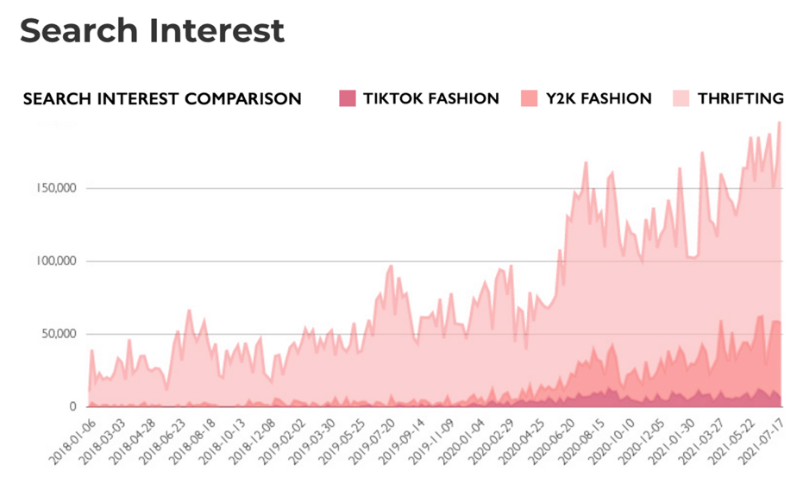
As shown in the graph above, Y2k fashion has shown an evident increase in search interest throughout the past year. Increase of significance can be shown starting from early 2020. This can be explained as a result of the pandemic and the mentioned factors that played a role in the increase of nostalgic feelings during that time. The trend however did not lose traction as a balanced eb and flow in the rise of this trend is evidenced. This mirrors the points made by Kristina Monllos on the endurance of nostalgia marketing as a result of the pandemic and the nostalgic effects it’s had on consumers (Monllos, 2021).


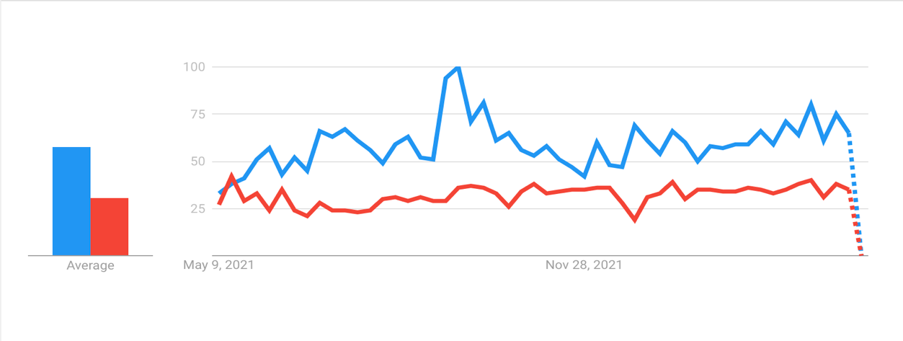
31
58

Shown above is a worldwide comparison of the google search trends of Y2K fashion in comparison to a newer fashion trend, Digital Fashion. The search trends shown are representative of the interest surrounding the two trends within the past year. Peak interest is measured at 100. The term Y2K fashion reached peak interest in September of 2021 and maintained a relatively high score throughout the year in comparison to the newer trend. As also shown, the average interest score for Y2K (58) was higher than that of digital fashion (31). Search interest trends are considered an effective tool when measuring demand in order to execute effective marketing strategies. This measuring tool ensures the targeted market has substantial interest in order to generate a more solid return on investment (Lincoln, 2020). The findings shown above have evidenced the increase in interest of Y2K fashion and how the nostalgic fashion trend outperforms the newer one in terms of interest. The findings have also evidenced an increase in demand, as mentioned search trends are effective in measuring demand. Demand, as previously stated, affects the way marketers approach their strategies (The Economist, 2018). Seeing how the demand for Y2K is becoming higher, marketers are more likely to utilise nostalgia marketing in order to cater to their audience’s needs.

Demand for nostalgia-based products and content, as mentioned, is increasing and the marketing response to this demand would also be mirrored. Further research has indicated that it is essential for marketing specialists to adapt their strategies in order to fit and tailor their content according to the up and coming or already established demands (The Economist, 2018). In this case, fashion marketers are adapting their strategies in order to fit the needs and demands of the current consumer. Hillary Hoffower mentions nostalgia fashion when discussing the key trends that are influencing consumer behaviour. Hoffower also states that fashion brands are tailoring their operations to fit the needs and demands of Gen Z (Hoffower, 2022). These demands include Gen Z’s Y2K obsession. The probability of the utilisation of nostalgia marketing in fashion can increase as a result of the increased demands and nostalgic trends. As mentioned, feeling nostalgic can influence consumers purchasing decisions and gear them towards more nostalgic products (Lasaleta et al., 2014). This is evidenced in the studies on self-continuity and nostalgia where evoking nostalgic feelings within the audience led to an increase in their purchase intent (Ju et al., 2016). This is highly beneficial to the relevance of nostalgia marketing because as mentioned purchase intent is considered to be one of the most important aspects of responses to marketing strategies (Montaño and Kasprzyk, 2015). Three marketing campaigns from the past two years with nostalgic cues will be analysed in order to showcase the mentioned probable shift in fashion marketing strategies.

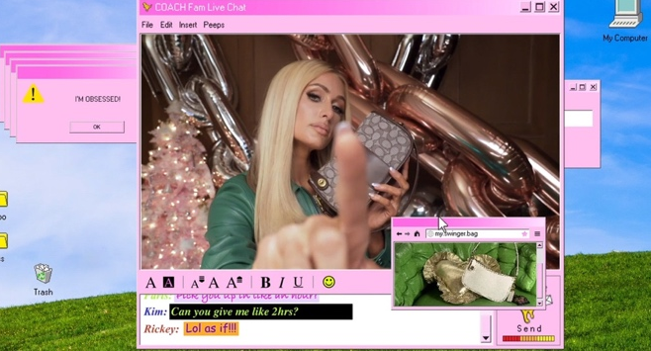

In December 2020, Fashion brand Coach chose media personality Paris Hilton, actor and internet personality Rickey Thompson and singer-songwriter Kim Petras to star in their holiday campaign for their Swinger bag (Allaire, 2020). The campaign featured the three personalities conversing in an AIM like chatroom. The AIM chatroom was popular during the Y2K era (Allaire, 2020). The campaign was able to exude nostalgic cues as it can be linked to several of the mentioned touch points. Feelings and relating are two of the touch points that could be considered the most relevant to this campaign as viewers who experienced this era and frequented AIM chatrooms could relate and feel a sense of nostalgia as a result of the cues embedded in the campaign. As evidenced in the studies analysed, this sense of nostalgia can then manifest into feelings of positivity towards the advertisement and the brand and could subsequently increase purchase intentions (Ju et al., 2016; Chou and Lien, 2010). As mentioned, individuals who feel nostalgic are more likely to invest in nostalgic products (Lasaleta et al., 2014), and the Swinger bag can be classified as a nostalgic product. The campaign also mirrors the statistics found on the Y2K trend. Increase in interest surrounding the Y2K trend can be seen starting in early 2020. By December of 2020, when this campaign was released, interest surrounding the Y2K trend was high. This can explain why Coach chose to shift their marketing strategies to a more nostalgic one in order to appeal to the demand.

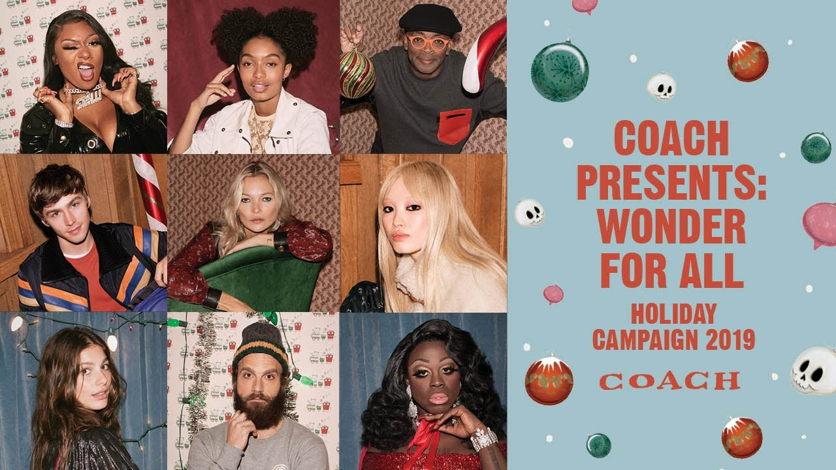

When comparing Coach’s Y2K inspired 2020 holiday campaign to their 2019 holiday campaign an evident difference can be seen. The 2019 campaign evidences more of the holiday spirit than the 2020 campaign. The Christmas holiday is considered to evoke nostalgia (Batcho, 2011), so the 2019 campaign naturally has nostalgic cues embedded in it. However, the intentional nostalgic cues are more evident in the 2020 campaign as they are implementing and featuring personalities and phenomenon’s of the past in order to evoke the nostalgic feeling. In other words, the nostalgic cues in the 2019 campaign naturally lend themselves to the advertisement whereas the 2020 campaign seems to have more thought-out and intentional nostalgic cues embedded throughout the advertisement.

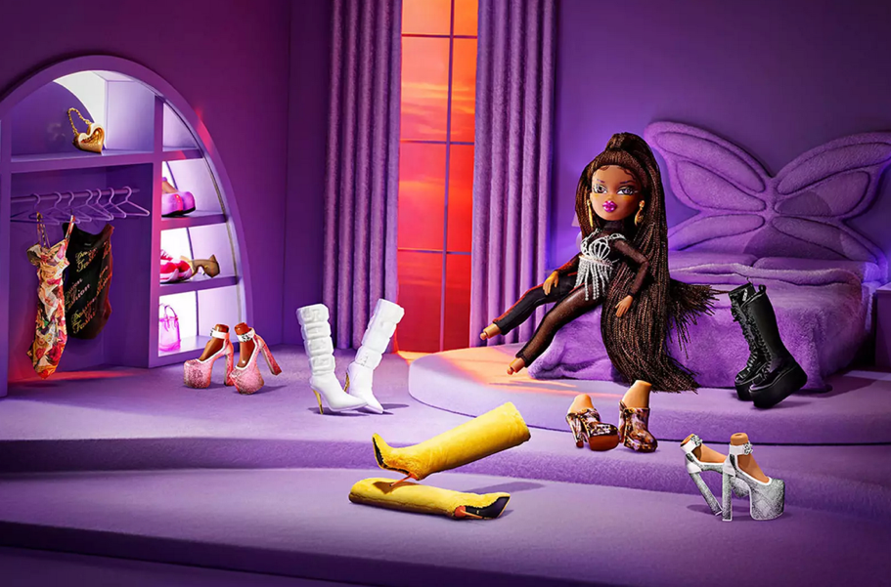

In November of 2021, fashion brand GCDS collaborated with doll brand Bratz on their Fall/Winter 2021 collection. The clothes worn by the dolls in the campaign is said to be aesthetically similar to the dolls original style (Pauly, 2021). The Bratz dolls and their distinct fashions are also considered to be a sort of symbol of the Y2K era (Pauly, 2021).
Similar to the Coach campaign, the GCDS collaboration with Bratz also showcases intentional nostalgic cues. The Bratz dolls themselves can be considered to be a nostalgic cue as they are a phenomenon of the past and can subsequently help the consumer connect with the campaign as it can elicit feelings of fondness within the viewers who experienced and relate to the Bratz era. Additionally, the shift to nostalgia marketing done by GCDS can also be witnessed.
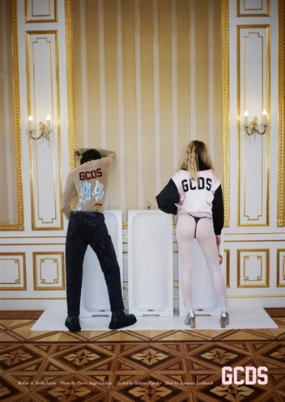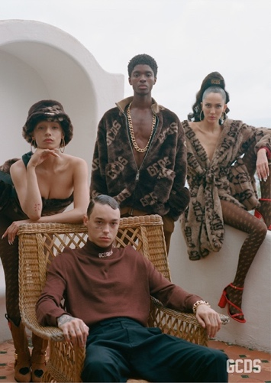

The brands 2019 and 2020 campaign, both shown above, exude less of a nostalgic aura in comparison to their 2021 campaign featuring Bratz. This can evidence the shift in marketing strategies to fit a more nostalgic theme. As shown in the graphs above, on the increase of interest in Y2K fashion, The GCDS shift in marketing strategies mirrors the increase of interest in the Y2K trend. As mentioned, research has shown that increase in trends can influence demand (Vogt, 2017) and demands subsequently influence marketing strategies (The Economist, 2018). It is probable that GCDS picked up on this increase in interest and tailored their strategies to fit the showcased increase.

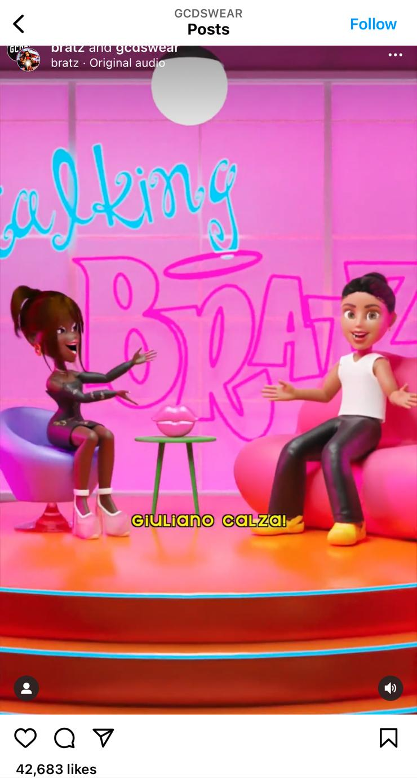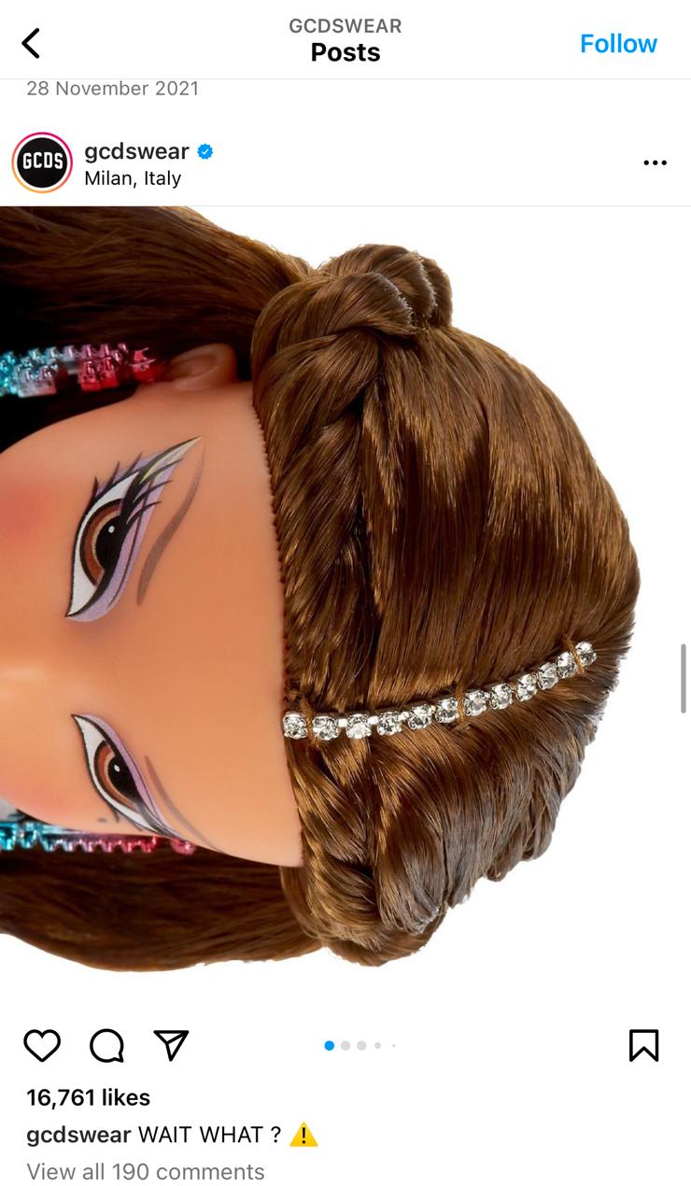

Shown above are Instagram posts of the Fall/Winter 2021 campaign found on the GCDS Instagram page. The posts garnered a substantial amount of likes in comparison to the 2020 and 2019 campaign posts shown below. This can also show the effect of nostalgia marketing on the viewer as the response to the more nostalgic campaign seemed to garner much more attention on social media than the 2020 and 2019 campaign.
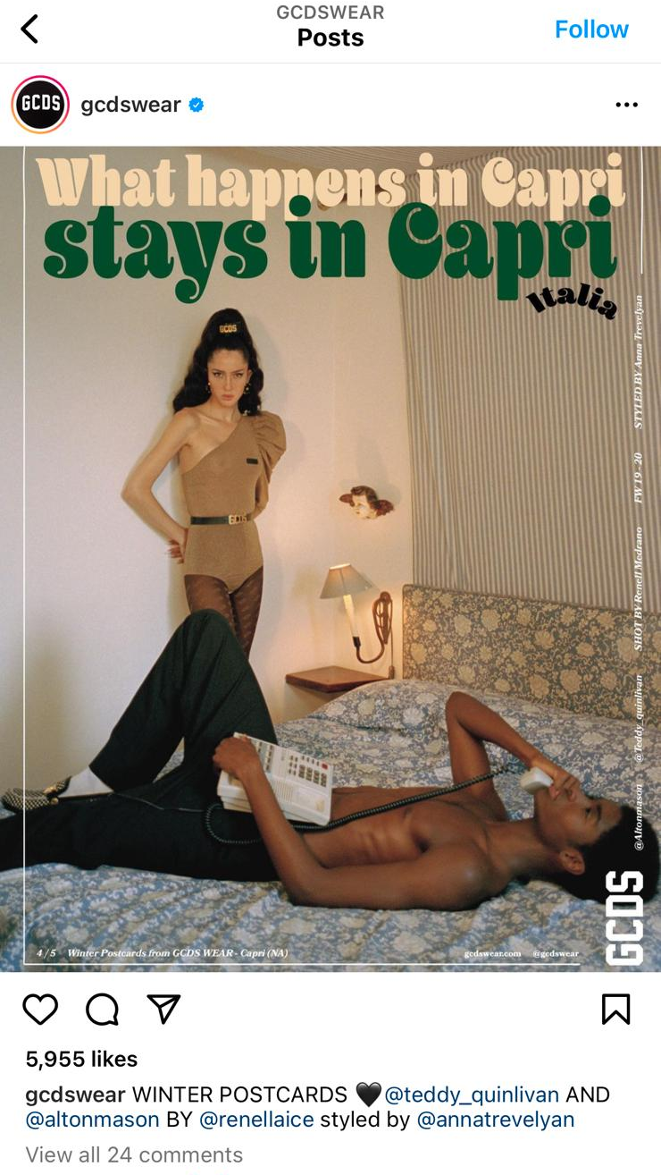

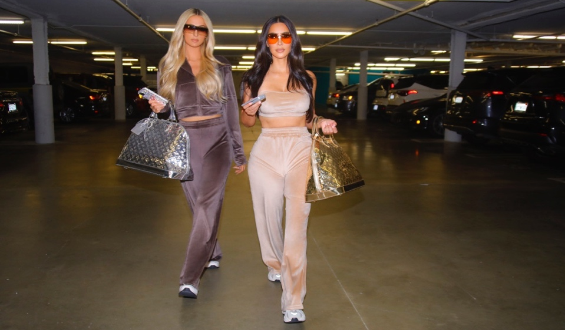

In October of 2020, media personality Kim Kardashian featured Paris Hilton in the campaign for Kardashians brand Skims new collection (Okwodu, 2020). The pair can be seen wearing tracksuits resembling the ones once made popular by Juicy Couture during the Y2K era. Kardashian also stated that she intentionally chose to incorporate the tracksuits into the collection as she wanted to integrate their nostalgic essence in the collection (Okwodu, 2020). The campaign appeared to be a success. The campaign revolved around the pair being photographed out and about similar to the way they were photographed together back in the Y2K era. The stills from the campaign that were published on Skims Instagram page received significantly higher amount of likes than the other posts published on the page.
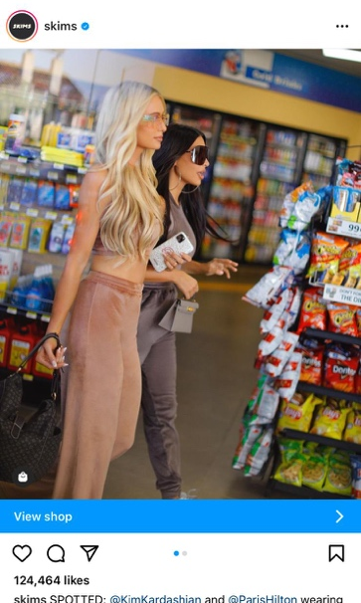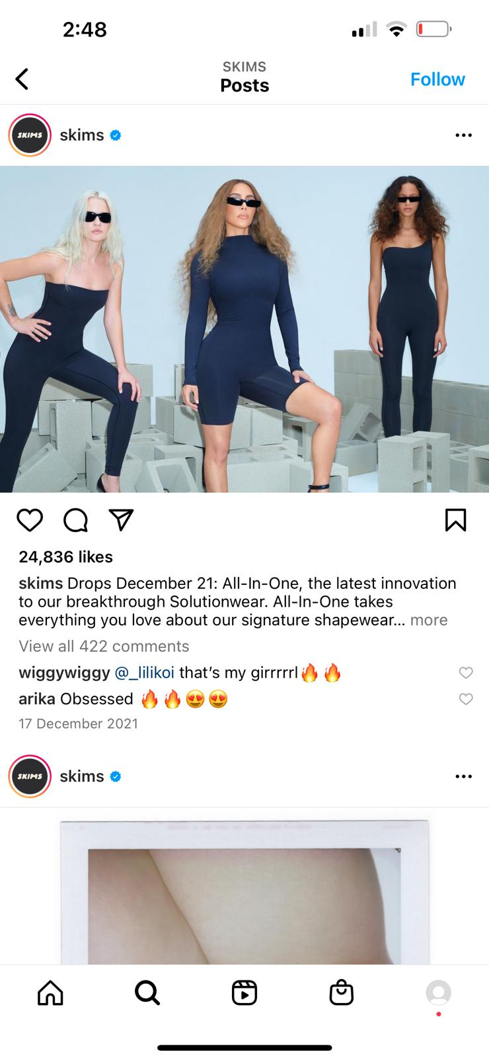
Shown above are the posts from the campaign in comparison to another campaign post found on Skims Instagram. As seen, the more nostalgic one has significantly more likes than the post with less nostalgic cues. This campaign, similarly, to the Coach campaign touches on feelings and relating for the same reasons as the Coach and GCDS campaigns. The campaign will also most probably evoke positive attitudes within the viewer and that will be projected onto the campaign itself. This is evidenced by looking at the number of likes received by the Instagram post of the nostalgic campaign in comparison to the less nostalgic post.

This campaign along with the Coach campaign and the GCDS campaign show the effect of nostalgia and nostalgic cues on the response to marketing campaign. The Coach and the GCDS campaigns showcase the shift in marketing strategies as a response to increase in interest surrounding the trend and the Skims and GCDS campaign showcased the effectivity of nostalgia cues in marketing campaigns as shown in the response to the posts on Instagram. Additionally, research has shown that nostalgic fashion advertisements on social media positively influence consumers reaction towards the advertisement and the brand and also influences purchase intentions (Youn and Jin, 2017). This can evidence the fact that the social media posts that featured more nostalgic cues received much more significant interest and attention in comparison to the less nostalgic posts. Additionally, Paris Hilton a being well-known figure and Bratz being popular phenomenon’s during the Y2K, can also evidence the impact of para-social relationships on nostalgia as the response from both campaigns seemed to garner significant attention.

    - Social Media Effect on Nostalgia Marketing in Fashion.
A factor that can play into the growing popularity of nostalgia marketing in fashion is social media. Today, tapping into nostalgic feelings has become more accessible than ever as nostalgic content is easily found throughout many social media platforms (Wildschut, 2016; Jacobsen and Beer, 2021). Research has shown that social media facilitates feelings of nostalgia. The significant role of social media in our day to day lives will subsequently make it easier for people to tap into their nostalgic feels. As mentioned, in trying times such as the lockdowns induced by the pandemic people have more space to indulge in nostalgia content (Pankowski, 2022) as it is widely accessible throughout multiple social media platforms. Additionally, the increase in focus on the Gen Z shopper (Hoffower, 2022) can be considered as a probable contributing factor to the growing usage of nostalgia marketing in fashion since as mentioned, nostalgic content is highly accessible throughout social media platforms (Wildschut, 2016; Jacobsen and Beer, 2021) and Gen Z are highly tech savvy and have grown up navigating their own unique spaces on social media platforms (Bradshaw, 2019). This can then allow them to find more inspiration from the past just like how they did with the Y2K trend by creating the nostalgic link between their needs of wanting to indulge in this trend as well as their developing affinity towards this specific era or other era’s. It is almost like a chain reaction that could have occurred. The pandemic hit and lockdowns were set in place, this led to more loneliness as evidenced in the detailed studies above, which ultimately led to a heightened need to indulge in nostalgia and nostalgic content. The wide accessibility of nostalgic content within social media platforms (Wildschut, 2016; Jacobsen and Beer, 2021) can ultimately heighten the probability of the revival of a nostalgic trend and that can lead to marketing specialists altering their strategies in order to fit the needs and demands of their consumers (The Economist, 2018) and a probability of utilising nostalgia marketing is then increased. The revival of various nostalgic trends can be evidenced by looking at the mentioned resurgence of fashion brands such as Juicy Couture and Blumarine (Kendall, 2021; Trendalytics, 2021) as well as the increase in interest surrounding the Y2K trend (Hoffower, 2022). The probability of the shift in marketing strategies to fit a nostalgic theme can be evidenced by looking at marketing strategies such as the mentioned GCDS and Bratz collaboration (Pauly, 2021).
Moreover, research has shown that nostalgia marketing strategies in social media can aid brands in forming connections with consumers as the nostalgic content evokes a sense of relation between the consumer and the brand. (Krawsczyk, 2021) Hence social media is widely considered to be an effective platform to implement nostalgia marketing strategies. In relation to fashion, as mentioned, studies have shown that nostalgic fashion ads on social media platforms can also induce positive attitudes within the viewer towards the post, the brand, and PI (Youn and Jin, 2017). Additionally, as stated, evoking a sense of nostalgia through social media can create a stronger connection between the brand and the consumer (Krawsczyk, 2021). It is highly probable that this also relates to fashion as evoking nostalgia through fashion advertisement has also evidenced positive reaction (Youn and Jin, 2021).
The nostalgia phenomenon in fashion can also be attributed to the current acceleration of fashion trend cycles. Fashion trends are estimated to have around a 20-year cycle until they re-emerge. Although this might still be the case today, an acceleration of trend revivals due to the impact of social media has been showcased throughout the years (Mollard, 2022). Due to social media, fashion trends today are considered to be much shorter in their life cycle and are also more randomly allocated with their re-emergence becoming less predictable than before. Since this can be explained as a result of the impact of social media, nostalgia and the revival of the trend can also be accelerated as well. Lauren Cochrane, Fashion Writer at The Face Magazine, mentions that the current acceleration of fashion trend revivals is due to the acceleration of nostalgia (Cochrane, 2022). This point can subsequently be linked back to the psychological findings on the triggers of nostalgia and why nostalgia-proneness is more common and evident today. In regard to the marketing response to the faster trend-cycles, the increase of demand surrounding a trend will lead to marketing techniques tailored to fit this demand (The Economist, 2018). The probability of the marketing techniques utilising nostalgic measures will subsequently also increase as, in today’s case, many of the fashion trends are considered nostalgic (Hoffower, 2022).

2.6 Summary of Lit Review

Based on the research conducted on nostalgia and nostalgia marketing, what is evident is that the effectivity of nostalgia marketing techniques lies within the psychological factors of nostalgia itself. As has been evidenced, nostalgia has been consistently linked with the evocation of positive attitudes and good moods within the viewer (REFERENCE). This in return showed a consistent positive attitude towards the brands, the advertisement, and purchase intent. Moreover, research has shown that, as of late, nostalgia-based trends in fashion have been increasing (Hoffower, 2022). This is further evidence by studies on the effects of the global pandemic and the mediating role nostalgia plays in enhancing the effects that were caused by the pandemic (Zhou et al., 2021). As nostalgic trends increased, a probability of an increase of nostalgia-based marketing can be predicted. Research has shown that marketers tend to shift their strategies in order to fit demand (The Economist, 2018) and demand is highly influenced by consumer behaviour and new trends (Vogt, 2017). Today, as research has shown, nostalgic fashion trends have been making a comeback and statistics and research have evidenced the increase in popularity of previous trends (Hoffower, 2022; Trendalytics, 2021). Further research has shown that people feeling nostalgic tend to invest in nostalgic products (Lasaleta et al., 2014). Seeing how the demand for nostalgic products is increasing, it is safe to say that the probability of nostalgia marketing strategies being implemented based on this demand will increase as well. Interviews conducted by the researcher on the impact of nostalgia fashion campaigns in comparison to more modern campaigns will be analysed in order to identify the effect of nostalgia marketing strategies in fashion. Moreover, the data gathered from the interviews will be compared to the research findings from the literature review.

Chapter 3: Methodology

3.1 Methodology

Findings from the literature review evidenced the effectivity of nostalgia marketing strategies and the positive responses from the consumers as a response to the nostalgic trigger. Hence, the researcher has conducted four interviews with fashion consumers in order to identify and analyse the effects of nostalgia marketing in relation to fashion advertisements. This chapter details the methods used to carry out the interviews as well as the methods used to analyse the data obtained from the interviews.

3.2 Research Question & Objectives

do the psychological effects of nostalgia play a role in the response of fashion consumers to nostalgia marketing strategies in fashion?

The objectives of the primary research are to:

- Identify and analyse fashion consumer responses to nostalgia marketing strategies in fashion.
- Identify and analyse fashion consumers response to non-nostalgic marketing strategies in fashion.
- Compare and contrast fashion consumers responses to both strategies.

3.3 Reasoning Behind Research Method:

Interviews were conducted in order to acquire data based on behavioural insights involving consumer responses to varying marketing strategies. Interviews are said to be a pivotal factor of qualitative research. The main reasoning behind interviews is to gather appropriate data that will subsequently aid in meeting the overall objectives of the research as well as complete the research aims (Phair and Warren, 2022). Conducting interviews will allow the researcher to do so by gathering the adequate data required to answer the research question. Additionally, the researcher will be able to identify consistent themes that arise as result of the interviews through the use of thematic analysis. Thematic analysis aids in identifying key themes of relevance to the researcher (Medelyan, 2019).

3.4 Research Structure:

    - Participants

It has been mentioned that there is no definitive set number of interviews required for qualitative data (Pascale, 2015). Additionally, interviews are also usually conducted with a smaller number of interviewees as the preparation time required to finalize the interview process, as well as the subsequent analysation of the data, is lengthy (Pascale, 2015). Four interviews were conducted with fashion consumers who have adequate knowledge on the fashion industry. The participants were chosen due to their knowledge of the fashion industry and their generational group. Six potential participants were contacted by the researcher through email and were asked if they would consider participating in an interview on fashion advertisements. Four of the potential participants replied and expressed interest in participating. The researcher then scheduled dates for the interviews to take place.
The researcher personally knows the participants. However, in order for there to be no bias, the researcher did not inform the participants about the purpose of the research. The researcher also tried to remain as neutral as possible. This was done in order to obtain unbiased results and maintain a balanced tone throughout the entirety of the interview.

    - Ethical consideration:

The research was approved by the Research Ethics Review Panel. Research began after the approval and the researcher commenced with preparations for the interviews. The participants all signed consent forms and will remain anonymous. The researcher approached the interviews with consideration and made sure all interviewees were comfortable. The data gathered through the interviews were stored in a password secured device owned by the researcher. The data will subsequently be deleted when there is no longer use for it.

    - Interview structure

The interviews were conducted online through Zoom as three of the interviewees were in different countries. The average interview time was 15 minutes with some lasting a bit longer. The interviewees were shown two fashion advertisement videos. The first video, Coach’s 2020 holiday campaign, included more nostalgic cues and elements. The second video, Balenciaga’s Fall 2021 campaign, was more futuristic and included less nostalgic cues in comparison to the Coach campaign. The videos were chosen due to their contrasting themes.
The researcher followed the semi-structured technique to conduct the interviews. Semi-structured interviews are conducted by predetermining a certain set of questions while also asking questions that were not planned in advance (Doyle, 2020). This allowed the researcher to ask questions relevant to the interviewees response in order to gain clearer understanding on an interviewees point of view. This also allowed the researcher to encourage elaboration if necessary.

    - Data Analysation:

The researcher utilised the thematic analysis method in order to find relevant themes shown throughout the conducted interviews. Thematic analysis is a type of qualitative data analysis. Qualitative data analysis is explained as the process of interpretation and analysation of qualitative data. (Medelyan, 2019). Through the use of thematic analysis, the researcher was able to code the transcripts obtained from the interview in order to come up with fitting themes for all four interviews and subsequently formulate results based on the themes. Additionally, the transcripts were coded in order to facilitate the identification of themes. Qualitative coding is also considered a thematic analysis (Medelyan, 2019). The Coach campaign was coded separately to the Balenciaga Campaign. This was done in order to have a clearer observation of the results as it would allow for a better comparison between the interviewees responses as well as the themes extracted from both strategies. this also helped the researcher distinguish between the answers generated through the interviews. The transcripts and the coded themes can be found in the appendix.

3.5 Interview Questions:

Can you describe what went through your mind when watching the advertisement?

This question is asked in order to obtain a clear understanding of the interviewee’s initial reaction towards the advertisement. It helps the researcher identify first impressions towards the ad and anticipate the tone of response towards the advertisements.

How did you feel after watching it?

This question is asked in order to understand the impression the advertisement left on the viewer. It helps the researcher determine how the interviewee viewed the advertisement and their afterthoughts regarding the theme of the advertisement.

Can you rate your attitude towards the advertisement from a scale of 1-10? 10 being very positive.

This question is asked in order to identify how positive the interviewee felt towards the advertisement. And is set in order to distinguish between the interviewees reaction to both advertisements and analyse accordingly. The rating will give the researcher a more solid overview of the interviewee’s reaction towards the advertisement.

Does your reaction to the advertisement influence your purchase intentions?

This question is asked in order to obtain a clearer understanding of what influences the interviewee’s purchase intentions. Additionally, it gives a clearer understanding of the interviewee’s overall response towards the advertisement. It also allows the researcher to analyse the influence of the interviewee’s response towards the advertisement on purchase intentions.

Can you rate your purchase intentions from a scale of 1-10? 10 being highly likely.

This question is asked in order to obtain a more solid understanding of the interviewee’s purchase intentions. It will also help the researcher with acquiring a clearer comparison between the interviewee’s purchase intentions for both advertisements.

Does your reaction to the advertisement influence your response to the brand?

This question is asked in order to obtain a clearer understanding of the interviewee’s reaction towards the brand. It also gives the researcher more insight on the influence of the advertisement on the interviewee’s response to the brand. It can also give insight on the influence of the brand on the advertisement depending on the preconceived ideas the interviewee has towards the brand.

Can you rate your attitude towards the brand from a scale of 1-10? 10 being very positive.

This question is asked in order to obtain a clearer understanding of the interviewees attitude towards the brand. This will also allow the researcher to compare the ratings of this question to both advertisements.

Can you rate how nostalgic you felt after watching the advertisement from a scale of 1-10? 10 being very nostalgic.

This question is intentionally placed as the last question. This question will be asked depending on the interviewee’s reaction towards the advertisement. If the participant expresses positivity towards the advertisement this question will then be asked. The question will also only be asked after watching the nostalgic fashion advertisement video. The question is asked in order to obtain a clearer understanding of the interviewee’s potential positive reaction. It will also allow the researcher to make links between the interviewee’s positive reactions and the elicitations of nostalgia along with any potential nostalgic themes evidenced throughout the interview.

Chapter 5: Findings and Results

5.1 Findings and Results

Several Interviews were conducted by the researcher to identify the effect of Nostalgia Marketing in fashion on the consumer. The studies detailed in the literature review, on the effect of nostalgia marketing on consumers, evidence the effectivity of nostalgia marketing in comparison to other marketing strategies. However, the studies did not test the effect of nostalgia marketing on fashion. Hence, the researcher conducted interviews with four fashion consumers in order to analyse the effect of nostalgia marketing on the viewer in comparison to more modern and futuristic themes.
The studies detailed in the previous chapter evidence the effectivity of nostalgia marketing in evoking a viewer’s positive attitudes and good moods towards the brand, the advertisement as well as their purchase intentions. The interview was conducted in order to find and gather results relating to the aforementioned consumer attitudes towards nostalgia marketing in fashion. Additionally, the researcher will analyse how the results compare or differ from previous results gathered on nostalgia marketing.

5.2 Interviewee Selection

As mentioned, four fashion consumers participated in the interviews. Two millennials and two Gen Z. The researcher chose to include different generational groups in order identify whether the perception of the ads will differ according to varying generational groups. Interviewee’s 1 and 2 are gen Z and Interviewees 3 and 4 are millennials.

5.3 Interview structure

The interviewees were shown two fashion advertisement videos. The first video, Coach’s 2020 holiday campaign, included more nostalgic cues and elements. The second video, Balenciaga’s Fall 2021 campaign, was more futuristic and included less nostalgic cues in comparison to the Coach campaign.
The researcher utilised the qualitative content analysis method in order to find relevant themes shown throughout the conducted interviews. Qualitative content analysis is a type of thematic analysis. Thematic analysis is the process of identifying themes from various sets of writing. Additionally, the transcripts were coded in order to facilitate the identification of themes. Qualitative coding is also considered a thematic analysis. The Coach campaign was coded separately to the Balenciaga Campaign. This was done in order to have a clearer observation of the results as it would allow for a better comparison between the interviewees responses as well as the themes extracted from both strategies.

5.4 Hypothesis:

Based on the studies analysed in the literature review, the researcher formulated several hypotheses. The hypotheses were based on the positive effects of nostalgia marketing on the consumer.

Hypothesis 1: The advertisement including nostalgic cues and themes will be perceived more positively by the participants in comparison to the less nostalgic advertisement.
Hypothesis 2: The participants will show preference towards the advertisement including nostalgic cues and themes.
Hypotheses 3: The advertisement including nostalgic cues will generate higher purchase intentions in participants to the less nostalgic advertisement.
Hypothesis 4: The advertisement Including nostalgic cues will have a positive effect on the participants reaction to the brand in comparison to the less nostalgic advertisement.
Hypothesis 5: The evocation of nostalgia will have a positive overall effect on the participants responses.

5.5 Coach Campaign Themes:

The ad evoked nostalgia.

- Interviewee 1: Interviewee 1 reminisced on “simpler times” as a response to the advertisement and alluded to having nostalgic feelings with the older means of online chatting featured in the advertisement serving as a prompt for the nostalgia-based feelings. Interviewee 1 also expressed sentiments regarding Coach’s intent in featuring nostalgic themes stating, “they’ve really capitalised on that early 2000’s excitement” (Interviewee 1, Response to Q1). Nostalgia rating: 7
- Interviewee 2: Interviewee 2 expressed feeling “taken back to the 2000’ era” (Interviewee 2, Response to Q1) as a response to the advertisement. Similarly to interviewee 1, interviewee 2 explained this as a result of the older means of online chatting as well as the older desktop style showcased in the advertisement. Interviewee 2 also mentions feeling “nostalgic and happy” as a result of watching the advertisement. Nostalgia rating: 9
- Interviewee 3: As a response to the advertisement, the third interviewee was reminded of “how things were back then” and expressed feeling happy as a result. Interviewee 3 also expressed feeling nostalgic as a response to the advertisement and mentions Paris Hilton’s involvement in the advertisement as one of the prompts for the nostalgic feels. Nostalgia Rating: 9
- Interviewee 4: When asked what came to mind after watching the advertisement, Interviewee 4 mentions “Barbie retro vibes” (Interviewee 4, Response to Q1). Interviewee 4 also comments on having a similar bag to the on being advertised and mentions how that “brought back some memories” (Interviewee 4, Response to Q1).

The ad evoked positive reactions as a result of the nostalgic cues.

- Interviewee 1: Interviewee 1 mentions how the advertisement elicited feelings of happiness due to the “style of computerisation” featured in the advertisement and explains how “iconic” this was for the time (Interviewee 1, Response to Q2).
- Interviewee 2: Interviewee 2 mentions the means of online chatting featured in the advertisement as a prompt for feeling “nostalgic and happy” (Interviewee 2, Response to Q10).
- Interviewee 3: Interviewee 3 reiterated the same sentiments made by Interviewee 1 and 2 on the effect of the 2000’s computer and chatting features being a prompt for feeling happy and mentions how these factors makes interviewee 3 “miss these times” (Interviewee 3, Response to Q9).
- Interviewee 4: Interviewee 4 says “I noticed that I smiled as soon as the ad came on.” (Interviewee 4, Response to Q2) and explains that as having to do with the bag showcased within the advertisement. Interviewee 4 reminisces on once having a similar bag to the one being advertised and explains that to be a prompt for the re-emergence of memories and how that made interviewee 4 smile.

Positive effect of nostalgia on consumer attitude towards the advertisement.

- Interviewee 1: Interviewee 1 mentions feelings of happiness as a response to the advertisement. Interviewee 1 also mentions how the feelings of happiness were due to the visual characteristics and also the 2000’s digital features embedded in the advertisement. Attitude towards the advertisement: 9
- Interviewee 2: Interviewee 2 mentions positively relating to the advertisement and attributing this reaction to the theme. Interviewee 2 also mentions Paris Hilton’s involvement in the advertisement to be another prompt for the aforementioned reaction. Attitude towards advertisement: 8.5
- Interviewee 3: Interview 3 mentions feeling good and uplifted and explains the advertisement to be a “mood booster” (Interviewee 3, Response to Q2). Interviewee also attributed the advertised product to be a prompt for the positive reaction and mentions enjoying “the sort of nostalgia it gives with the whole 2000’s vibes.” Attitude towards advertisement: 8
- Interviewee 4: Interviewee 4 mentions feeling happy as a result of watching the advertisement. Attitude towards advertisement: 9

Positive effect of nostalgia on purchase intentions.

- Interviewee 1: Interviewee 1 validates high purchase intentions by saying “it almost feels like you’ve missed such an iconic time, so you’d want to experience that again.” (Interviewee 1, Response to Q5). Attitude towards purchase intentions: 8
- Interviewee 2: Interviewee 2 mentions affinity towards the brand as well as nostalgic cues found throughout the advertisement when validating high purchase intentions. Attitude towards purchase intentions: 8
- Interviewee 3: Interviewee 3 mentions a liking towards the product when validating high purchase intentions. Interviewee 3 also mentions the way the product was advertised as a prompt for high purchase intentions. Attitude towards purchase intentions: 8
- Interviewee 4: Interviewee 4 mentions the positive reaction towards the advertisement as well as once having a similar bag as a prompt for high purchase intentions. Attitude towards purchase intentions: 9

Positive effect of nostalgia on attitude towards the brand.

- Interviewee 1: Interviewee 1 attributes the brands recognition of their relevance during the 2000’s era and the fact that they are “capitalising on this new resurgence” (Interviewee 1, Response to Q7) of the Y2K aesthetic as a prompt for a positive attitude towards the brand. Attitude towards brand: 9
- Interviewee 2: Interviewee 2 mentions an affinity towards the brand as a prompt for a positive reaction towards the brand. Interviewee 2 also mentions that the advertisement itself plays a role in the positive response to the brand. Attitude towards the brand: 8
- Interviewee 3: Interviewee 3 also mentions how the advertisement played a factor in the positive response towards the brand. Attitude towards brand: 7
- Interviewee 4: Interviewee 4 also reiterates what was stated by interviewee 2 and 3 by saying that the advertisement was the prompt for the positive reaction towards the brand. Attitude towards brand: 8

Balenciaga Campaign Themes:

Lack of connection with the advertisement.

- Interviewee 1: Interviewee 1 states that “It just seems very unapproachable and just too different...” (Interviewee 1, Response to Q11). Interviewee 1 also considered the advertisement to be “too distracting” (Interviewee 1, Response to Q11). Attitude towards the advertisement: 4.5/5
- Interviewee 2: interviewee 2 mentions how the advertisement was “Innovative” (Interviewee 2, Response to Q2) and finds positivity when speaking about “the futuristic element of it in terms of fashion” (Interviewee 2, Response to Q3). However, interviewee 3 also felt a lack of connection with the advertisement stating, “I don’t feel like I can relate to it.” (Interviewee 2, Response to Q3) Attitude towards advertisement: 5
- Interviewee 3: Interviewee expressed liking the concept of the advertisement but also explains a lack of connection stating, “…nothing connected with me in terms of fashion.” (Interviewee 3, Response to Q12). Attitude towards advertisement: 5
- Interviewee 4: Interviewee 4 also expressed confusion. Stating, “I was a bit confused. Not really knowing what the advertisement was for.” (Interviewee 4, Response to Q14). Attitude towards advertisement: 5

Lower Purchase Intentions.

- Interviewee 1: Interviewee 1 states, “I couldn’t really pinpoint or pin down items of clothing I like that they’ve shown because everything was too distracting…it didn’t really do much for me.” (Interviewee 1, Response to Q15). Attitude towards purchase intentions: 3
- Interviewee 2: Interviewee 2 states, “I feel like because I couldn’t relate to it, I wouldn’t really want to buy anything.” (Interviewee 2, Response to Q19). Attitude towards purchase intentions: 5
- Interviewee 3: Interviewee 3 attributes the digitalised fashion in the advertisement for the low purchase intent. Interviewee 3 expresses an inability to relate due to the digitalised presentation of the clothing in the advertisement. Attitude towards purchase intentions: 4
- Interviewee 4: Interviewee 4 mentions how the purchase intent was only influenced when the brand was introduced. Attitude towards purchase intentions: 4

Lower connection with the brand.

- Interviewee 1: Interviewee 1 states, “I think in my opinion it’s not a brand for me…” (Interviewee 1, Response to Q17). Interviewee 1 also expresses an understanding of the brands ethos but also expresses similar sentiments to the one mentioned. Attitude towards the brand: 5
- Interviewee 2: Interviewee 2 mentions not being able to identify the direction the brand was taking and attributes that as a reason for the low connection to the brand. Attitude towards the brand: 5
- Interviewee 3: Interviewee 3 mentions the futuristic element of the advertisement when talking about not being able to relate to the brand and states, “I think the ad being so futuristic doesn’t really help me relate to it in a way.” (Interviewee 3, Response to Q18). Attitude towards the brand: 4
- Interviewee 4: Interviewee 4 mentions the advertisement when expressing the reason for not being able to connect to the brand, stating, “I’ve seen previous ads and they’re not always the same concept for different campaigns. But this particular ad just didn’t do it for me really.” (Interviewee 4, Response to Q20). Attitude towards the brand: 5

Preference towards the Coach Campaign.

- Interviewee 1: Interviewee 1 expressed higher purchase intentions for the Coach advertisement, stating, “I couldn’t pay attention to the clothing that were on the AI’s so yeah it didn’t really do much for me.” (Interviewee 1, Response to Q15) when explaining why purchase intentions were higher for the Coach advertisement.
- Interviewee 2: Interviewee 2 also mentioned clear preference towards the Coach advertisement. Stating, “I feel like I can definitely relate to the coach ad way more because of the way they portray the 2000’s era.” (Interviewee 2, Response to Q21).
- Interviewee 3: Interviewee 3 also mentions a clear preference towards the Coach advertisement and states, “Even though it was shorter and had a much simpler storyline, I felt it was much more straight to the point and kind of captured my attention more. I think also I could connect with it more with the sort of nostalgia part of it. It made me feel more if that makes sense.” (Interviewee 3, Response to Q13)
- Interviewee 4: When asked to compare purchase intentions between both advertisements, Interviewee 4 states, “I prefer the first one to tell you the truth. Only because I could relate to it more than this one.” (Interviewee 4, Response to Q26).

Chapter 6: Discussions

6.1 Discussion:

The results from the interviews show a clear preference towards the advertisement with more nostalgic cues. Hence, H2 is supported. The interviewees attitude towards the advertisement, the brand, and purchase intentions were shown to be consistently positive. Hence, H1, H3, H4 , and H5 are supported. Additionally, the prompt for the positive attitudes were a result of the nostalgic triggers found within the advertisement. Interviewee 3 mentions, “remembering these old ways of communicating and chatting made me feel happy and also makes me miss these times. Especially seeing how a lot has changed since then makes me miss it even more in a way and watching this really did that.” (Interviewee 3, Response to Q1). This shows congruence with previous research conducted on the effect of nostalgia marketing strategies where they were found to elicit higher feelings of positivity towards the advertisement (Ju et al., 2016; Chou and Lien, 2010). The touch point that was expressed the most by the interviewees was relating. The interviewees consistently mentioned how they could “relate” to the advertisement and as a result their attitude towards the brand was positively influenced. However, in the case of interviewee 2, an already developed relationship with the brand was observed. This presented a probability of bias towards the shown advertisement by interviewee 2. Although, a sense of enhancement in interviewee 2’s attitude towards the brand as a result of watching the advertisement was also shown. This was observed when interviewee 2 stated, “…I do love the brand but the ad itself kind of added to that just from the themes and the look of it and the way it took me back to that time when I was growing up.” (Interviewee 2, Response to Q7). The results from the second advertisement, the Balenciaga advertisement, evidenced less enthusiasm towards the advertisement and the brand as well as purchase intentions. Some interviewees, such as interviewee 2 and interviewee 3, expressed some positivity towards the advertisement with interviewee 2 stating, “This campaign was very cool and very futuristic it felt kind of like a simulation, kind of like a black mirror episode.” (Interviewee 2, Response to Q11) and interviewee 3 stating, “I did like it as a concept…” (Interviewee 1, Response to Q12). However, both interviews then expressed similar sentiments aforementioned by interviewees 1 and 4. The theme of these sentiments were that the interviewees couldn’t relate or connect with the advertisement or the brand. This then affected the interviewee’s attitudes towards their purchase intentions. The interviewees then showed preference to the Coach advertisement with some expressing how the nostalgic cues played a part in their preference. This was evidenced by all the interviewees at varying points in the interviews.
The Balenciaga advertisement, as evidenced, was received less positively by the interviewees, in comparison to the Coach advertisement. However, it can be predicted that consumers whose personal style fits the Balenciaga aesthetic and subsequently fits the themes portrayed in the Balenciaga advertisement would react more positively to the Balenciaga advertisement. According to Carolyn Mair, fashion is a reflection of one’s identity and translates the way individuals would prefer to present themselves. (Mair, 2018). this can then lead to a high probability of individuals who enjoy the Balenciaga aesthetic to react more positively to the Balenciaga advertisement in comparison to the Coach advertisement. Hence, if the number of participants of this research was significantly higher, a higher probability of more positive reactions to the Balenciaga ad can be expected.
Judging by the research found and detailed in the literature review on the effect of nostalgia marketing on consumers as well as the interviews conducted on the effect of nostalgia marketing on fashion, it can be assumed that nostalgia marketing in fashion is an effective strategy as it exudes positive responses from the consumer towards the brand and the advertisement and also positively influences purchase intentions.

6.2 Conclusion:

To conclude, the findings from the literature review showed the significant positive effect of nostalgia marketing strategies on the consumer as well as the psychological effect of nostalgia on the consumer. The results gathered through the interviews, on the positive effects of nostalgia marketing in fashion on the consumer, showed congruence to the findings from the literature review. The results from the interviews evidenced the effectivity of nostalgia marketing in fashion in comparison to less nostalgic fashion advertisements, fulfilling the objectives of this study and answering the research question.

6.3 Limitations:

Several limitations were brought forth during the process of this research. There were several research studies on nostalgia marketing’s effect on consumers that utilised experimental approaches and more expansive samples (Ju et al., 2016; Chou and Lien, 2010). although the results from this research were congruent with findings from results of similar researches on the effects of nostalgia marketing strategies, a much more expansive study, with larger samples, on the effects of fashion-based nostalgia marketing strategies on the consumer could be conducted. Additionally, limitations were observed during the interview process as scheduling became an issue. Some interviewees were in a different time-zone from the researcher. This caused scheduling problems and delays with some interviews as the differences in time-zones were significant.

7. References:

Youn, S. and Jin, S., 2017. Reconnecting with the past in social media: The moderating role of social influence in nostalgia marketing on Pinterest. Journal of Consumer Behaviour, 16(6), pp.565-576.

Breakell, K. (2021), ‘Why We Keep Returning To The 'Best' Decades In Fashion, According To Experts
’. Interview by Nicole Kliest, TZR, 2.5.2021.

Rettie, H., & Daniels, J. (2021). Coping and tolerance of uncertainty: Predictors and mediators of mental health during the COVID-19 pandemic. American Psychologist, 76(3), 427-437. http://dx.doi.org/10.1037/amp0000710

Xin, M., Luo, S., She, R., Yu, Y., Li, L., Wang, S., . . . Lau, J. T.-f. (2020). Negative cognitive and psychological correlates of mandatory quarantine during the initial COVID-19 outbreak in China. American Psychologist, 75(5), 607-617. http://dx.doi.org/10.1037/amp0000692

Zacher, H., Rudolph, C. W. (2020). Individual differences and changes in subjective wellbeing during the early stages of the COVID-19 pandemic. American Psychologist, 76(1), 50–62. http://doi.org/10.1037/amp00007

Armitage, R., Nellums, L. B. (2020). COVID-19 and the consequences of isolating the elderly. The Lancet: Public Health, 5(5), E256. https://doi.org/10.1016/S2468-2667(20)30061-X

Enea, V., Eisenbeck, N., Petrescu, T. C., Carreno, D. F. (2021). Perceived impact of quarantine on loneliness, death obsession, and preoccupation with God: Predictors of increased fear of COVID-19. Frontiers in Psychology, 12, 643977. https://doi.org/10.3389/fpsyg.2021.643977

Wildschut, T., Sedikides, C., Arndt, J., Routledge, C. (2006). Nostalgia: Content, triggers, functions. Journal of Personality and Social Psychology, 91(5), 975–993. https://doi.org/10.1037/0022-3514.91.5.975

Quay, A. (2021), ‘Marketing Briefing: ‘In times of uncertainty, we crave familiarity’: Why nostalgia marketing is everywhere right now’. Interview by Kristina Monllos, DIGIDAY, 28.9.2021.

Tim Wulf & Diana Rieger (2018) Wallowing in Media Past: Media-Induced Nostalgia’s Connection to Parasocial Relationships, Communication Research Reports, 35:2, 178-182, DOI: 10.1080/08824096.2017.1383236

Hartmann, T. (2016). Parasocial interaction and parasocial relationships. In L. Reinecke & M. B. Oliver (Eds.), The Routledge handbook of media use and well-being (pp. 131–144). New York, NY: Routledge.

Hartmann, T. (2010). Parasoziale Interaktion und Beziehungen. [Parasocial interactions and relationships]. Baden-Baden, Germany: Nomos.

Slappendel, C. (1996). Perspectives on innovation in organizations. Organization Studies, 17(1), 107-129

Boden, M.A. (1997). The constraints of knowledge. In Å.E. Andersson and N.E. Sahlin (eds.) The complexity of creativity, 1-4. Dordrecht: Kulwer Academic Publishers.

Wildschut, T. (2016), ‘Why Are Millennials The Most Nostalgic Generation Ever?’. Interview by Vicky Spratt, GRAZIA, 28.3.2016

Batcho, K. (2019) ‘Speaking of Psychology: Does nostalgia have a psychological purpose?’. Interview by Kaitlin Luna. American Psychological Association. 09.2019.

Abramson, A. (2019) ‘Why Nostalgic Fashion Holds a Deeper Meaning for Millennials’. Interview by Angela Velasquez. Rivet. 11.10.2019.

Kumar, Rakesh and Kaushal, S. K., Influence of Attitude Towards Advertisement on Purchase Intention: Exploring the Mediating Role of Attitude Towards Brand Using SEM Approach (November 22, 2017). The IUP Journal of Marketing Management, Vol. XV, No. 4, November 2016, pp. 44-59, Available at SSRN: https://ssrn.com/abstract=3075718

Barbara B. Stern (1992) Historical and Personal Nostalgia in Advertising Text: The Fin de siècle Effect, Journal of Advertising, 21:4, 11-22, DOI: 10.1080/00913367.1992.10673382

Christopher Marchegiani & Ian Phau (2010) Away from “Unified Nostalgia”: Conceptual Differences of Personal and Historical Nostalgia Appeals in Advertising, Journal of Promotion Management, 16:1-2, 80-95, DOI: 10.1080/10496490903572991

Muehling, D.D. and Sprott, D.E. (2004), “The power of reflection: an empirical examination of nostalgia advertising effects”, Journal of Advertising, Vol. 33 No. 3, pp. 25‐35.

Williams, J.L. and Faber, R.J. 1999. “Everything old is new again: The use of nostalgia appealsin advertising”. In Association for Education in Journalism and Mass Communication Convention's Advertising Division New Orleans, LA

Petty, R.E., Schumann, D.W., Richman, S.A. and Strathman, A.J. 1993. Positive mood and persuasion: Different roles for affect under high- and low-elaboration conditions. Journal of Personality and Social Psychology, 64(1): 5–20.

Allan, D. 2006. Effects of popular music in advertising on attention and memory. Journal of Advertising Research, 46(4): 434–44.

Bluck, S. and Alea, N. (2008), “Remembering being me: the self-continuity function of autobiographical memory in younger and older adults”, in Sani, F. (Ed.), Self-continuity: Individual and Collective Perspectives, Psychology Press, New York, NY, pp. 55-70.

Bradshaw, J., 2019. Council Post: What's Different About Generation Z Tech Talent?. [online] Forbes. Available at: <https://www.forbes.com/sites/forbestechcouncil/2019/03/13/whats-different-about-generation-z-tech-talent/?sh=4b972cb01f50> [Accessed 5 May 2022].

Everett, K., 2020. The 2020 Boom of Nostalgia Marketing | TWI. [online] TWI. Available at: <https://twi.agency/2020-boom-of-nostalgia-marketing/> [Accessed 5 May 2022].

Hoffower, H., 2022. Gen Z brought the '90s back because it feels impossible to grow up in today's economy. [online] Business Insider. Available at: <https://www.businessinsider.com/gen-z-nostalgia-y2k-indie-sleaze-old-money-economic-response-2022-1?r=US&IR=T> [Accessed 5 May 2022].

Hoffower, H., 2020. Younger workers are hit hardest in the coronavirus job market, and it spells bad news for millennials and Gen Z. [online] Business Insider. Available at: <https://www.businessinsider.com/millennials-gen-z-laid-off-furloughed-coronavirus-job-market-2020-4?r=US&IR=T> [Accessed 5 May 2022].

Jacobsen, B. and Beer, D., 2021. Quantified Nostalgia: Social Media, Metrics, and Memory. Social Media + Society, 7(2), p.205630512110088.

Kumar, A., 2019. Here’s What the Millennial Approach to Fashion is all About. [online] Entrepreneur. Available at: <https://www.entrepreneur.com/article/331969> [Accessed 5 May 2022].

McDonald, T., 2017. Nostalgia BOOM: Demand for retro items increases during global crises, study finds. [online] Express.co.uk. Available at: <https://www.express.co.uk/life-style/life/810021/nostalgia-retro-items-vintage-clothes-demand-increase-global-crisis> [Accessed 5 May 2022].

Moawad, H., 2016. The Brain and Nostalgia. [online] Neurology live. Available at: <https://www.neurologylive.com/view/brain-and-nostalgia> [Accessed 5 May 2022].

Monllos, K., 2021. Marketing Briefing: 'In times of uncertainty, we crave familiarity': Why nostalgia marketing is everywhere right now. [online] Digiday. Available at: <https://digiday.com/marketing/marketing-briefing-in-times-of-uncertainty-we-crave-familiarity-why-nostalgia-marketing-is-everywhere-right-now/> [Accessed 5 May 2022].

Montgomery, J., 2020. Why I Think Nostalgia Is the Future of the Fashion Industry. [online] Who What Wear UK. Available at: <https://www.whowhatwear.co.uk/nostalgia-fashion-trend/slide2> [Accessed 5 May 2022].

Newman, K., 2019. World Happiness Report Finds That People Are Feeling Worse. [online] Greater Good. Available at: <https://greatergood.berkeley.edu/article/item/world_happiness_report_finds_that_people_are_feeling_worse> [Accessed 5 May 2022].

Rosenblatt, K. and Wilson, L., 2021. Gen Z's 'nowstalgia' for Y2K fashion is leading to a thrifting explosion. [online] NBC News. Available at: <https://www.nbcnews.com/pop-culture/pop-culture-news/gen-z-s-nowstalgia-y2k-fashion-leading-thrifting-explosion-n1274720> [Accessed 5 May 2022].

Vinney, C., 2021. What Is a Parasocial Relationship?. [online] Verywell Mind. Available at: <https://www.verywellmind.com/what-is-a-parasocial-relationship-5210770> [Accessed 5 May 2022].

Wulf, T., Breuer, J. and Schmitt, J., 2021. Escaping the pandemic present: The relationship between nostalgic media use, escapism, and well-being during the COVID-19 pandemic. Psychology of Popular Media,.

Zhou, X., Sedikides, C., Mo, T., Li, W., Hong, E. and Wildschut, T., 2021. The Restorative Power of Nostalgia: Thwarting Loneliness by Raising Happiness During the COVID-19 Pandemic. Social Psychological and Personality Science, p.194855062110418.

J, M., Mitra, S., Bhooshety, L. lkogretim Online, Elementary Education Online,Year; Vol 20 (Issue 5): pp.1820-1831, http://ilkogretim-online.org, doi: 10.17051/ilkonline.2021.05.200

Chou, H. and Lien, N., 2010. Advertising effects of songs' nostalgia and lyrics' relevance. Asia Pacific Journal of Marketing and Logistics, 22(3), pp.314-329.

Ju, I., Kim, J., Chang, M. and Bluck, S., 2016. Nostalgic marketing, perceived self-continuity, and consumer decisions. Management Decision, 54(8), pp.2063-2083.

Lasaleta, J., Sedikides, C. and Vohs, K., 2014. Nostalgia Weakens the Desire for Money. Journal of Consumer Research, 41(3), pp.713-729.

William J. Havlena and Susan L. Holak (1991) ,"&Quot;The Good Old Days&Quot;: Observations on Nostalgia and Its Role in Consumer Behavior", in NA - Advances in Consumer Research Volume 18, eds. Rebecca H. Holman and Michael R. Solomon, Provo, UT : Association for Consumer Research, Pages: 323-329.

Jamali, Alexandra P., "A history of reminiscences : clinical descriptions of nostalgia, psychodynamic‬‬‬
theories of mourning, and the confluence of teleology" (2012). Masters Thesis, Smith College,‬ Northampton, MA.‬‬‬‬‬
https://scholarworks.smith.edu/theses/915‬‬‬

Gannon, Kathleen, "Parasocial Relationships with Fictional Characters in Therapy" (2018).‬ Expressive Therapies Capstone Theses. 77.‬ https://digitalcommons.lesley.edu/expressive_theses/77‬‬‬‬‬‬‬‬‬
‬
‬Batcho, K., 2017. The psychological benefits – and trappings – of nostalgia. [online] The Conversation. Available at: <https://theconversation.com/the-psychological-benefits-and-trappings-of-nostalgia-77766> [Accessed 5 May 2022].

Cochrane, L., 2022. Our obsession with nostalgia is driving a trend revival spiral. [online] The Face. Available at: <https://theface.com/culture/the-revival-spiral-1990s-2000s-noughties-nostalgia-indie-sleaze-y2k-tiktok-fashion-dark-academia-regencycore-the-sopranos-supreme> [Accessed 5 May 2022].

Harvey, E., 2011. 'Retromania': Why Is Pop Culture Addicted to Its Own Past?. [online] The Atlantic. Available at: <https://www.theatlantic.com/entertainment/archive/2011/08/retromania-why-is-pop-culture-addicted-to-its-own-past/242868/> [Accessed 5 May 2022].

Harvey, S., n.d. Passion For The Past: Nostalgia Marketing And The Retro Revolution. [online] Fabrik Brands. Available at: <https://fabrikbrands.com/nostalgia-marketing/> [Accessed 5 May 2022].

Heinberg, M. and Katsikeas, C., 2019. Why are brands with a nostalgic touch successful?. [online] Business.leeds.ac.uk. Available at: <https://business.leeds.ac.uk/research-glosmarc/dir-record/research-blog/1500/why-are-brands-with-a-nostalgic-touch-successful> [Accessed 5 May 2022].

Mollard, M., 2022. Understanding fashion trend life cycles: The 5 stages. [online] Heuritech. Available at: <https://www.heuritech.com/articles/five-stages-of-fashion-trend-life-cycle/> [Accessed 5 May 2022].

Raza, M., Abd Rani, S. and Md Isa, N., 2020. DETERMINANTS OF BRAND AUTHENTICITY OF HIGH QUALITY APPAREL INDUSTRY IN DEVELOPING COUNTRY: A MODERATING EFFECT OF ENTREPRENEURIAL. International Journal for Quality Research, 14(3), pp.913-930.

Sedikides, C., Wildschut, T., Arndt, J. and Routledge, C., 2008. Nostalgia. Current Directions in Psychological Science, 17(5), pp.304-307.

The Economist, 2022. Business Reality Check. [online] Businessrealities.eiu.com. Available at: <https://businessrealities.eiu.com/in-brief-shifting-customer-demands> [Accessed 5 May 2022].

Vizard, S., 2016. [online] Available at: <https://www.marketingweek.com/consumer-trust-in-brands-on-social-media-falls-as-line-between-marketing-and-non-commercial-blurs/> [Accessed 5 May 2022].

Vogt, C., 2017. What Factors Force a Shift in a Demand Curve?. [online] Small Business - Chron.com. Available at: <https://smallbusiness.chron.com/factors-force-shift-demand-curve-25441.html> [Accessed 5 May 2022].
Pascale, K (2015) Conducting in-depth interviews with consumers. Kate Pascale and Associates Pty. Ltd.
Melbourne, Vic
Allaire, C., 2020. Paris Hilton On Her New Coach Campaign, The Return Of Y2K Style And The Irreplaceable Bags The ‘Bling Ring’ Took. [online] British Vogue. Available at: <https://www.vogue.co.uk/news/article/paris-hilton-coach-campaign> [Accessed 13 May 2022].

Bouchrika, I., 2021. [online] Available at: <https://research.com/research/primary-research-vs-secondary-research> [Accessed 13 May 2022].

Doyle, A., 2020. What Is a Semi-Structured Interview?. [online] The Balance Careers. Available at: <https://www.thebalancecareers.com/what-is-a-semi-structured-interview-2061632> [Accessed 13 May 2022].

Medelyan, A., 2019. Coding Qualitative Data: How To Code Qualitative Research (2021) | Thematic. [online] Thematic. Available at: <https://getthematic.com/insights/coding-qualitative-data/> [Accessed 13 May 2022].

Oh, H., Prado, P., Korelo, J. and Frizzo, F., 2019. The effect of brand authenticity on consumer–brand relationships. Journal of Product &amp; Brand Management, 28(2), pp.231-241.

Okwodu, J., 2020. Kim Kardashian West and Paris Hilton on Bringing Velour Tracksuits Back for SKIMS. [online] Vogue. Available at: <https://www.vogue.com/article/skims-velour-collection-kim-kardashian-west-paris-hilton> [Accessed 13 May 2022].

Onwuegbuzie, A. and Weinbaum, R., 2017. [online] Nsuworks.nova.edu. Available at: <https://nsuworks.nova.edu/cgi/viewcontent.cgi?article=2175&context=tqr> [Accessed 13 May 2022].

Phair, D. and Warren, K., 2022. How To Do Qualitative Interviews (+ Free Interview Guide) - Grad Coach. [online] Grad Coach. Available at: <https://gradcoach.com/qualitative-interviews/> [Accessed 13 May 2022].

Simister, N. and Scholz, V., 2017. [online] Intrac.org. Available at: <https://www.intrac.org/wpcms/wp-content/uploads/2017/01/Qualitative-comparative-analysis.pdf> [Accessed 13 May 2022].

Youn, S. and Jin, S., 2017. Reconnecting with the past in social media: The moderating role of social influence in nostalgia marketing on Pinterest. Journal of Consumer Behaviour, 16(6), pp.565-576.

Appendix 1 (Transcripts):

(Coach campaign video was shown)

R. Q1: Can you describe what went through your mind when watching the video?

I.1. RQ1: I think my initial reaction to that advertisement is how colourful It was and how it alludes to a simpler time and a time in our lives that we may never really get back. Like with MSN, AIM, AOL those chat sites remind me of being in middle school and chatting with friends. And also, with the brand being coach and that was really big in the 2000’s. It’s interesting how they’ve really capitalised on that early 2000’s excitement and just that time and theme. And also having Paris Hilton in the video as well, being such an icon of that time and such a staple of pop culture and mixing it with Rickey Thompson who’s a huge influencer of our time so It’s like a good collaboration between the past and the present.

R. Q2: and how did you feel after watching? So after the video was over what impression did it leave on you?

I.1. RQ2: Slightly melancholic for a past that we won’t see anymore. It was like bittersweet. It made me happy because of how colourful it was and how distinct that style of computerisation was and how iconic that is to that time. So, it almost makes you reflect on that time of your life so in a bittersweet way.

R. Q3: Ok. And can you rate from a scale of 1-10 your attitude towards the ad? 10 being very positive.

I.1. RQ3: I think I would give it a solid 9. I think particularly just because during that time and that style of computer technology I was still pretty young so I wouldn’t have been fully experiencing that, it was probably on its way out of fashion but then due to my more personal experiences having older sisters who were properly in the swing of that time. It’s almost nostalgic in wanting to participate in that experience. So yes, that’s why I would give it a 9. Just because you want to have been part of it, but you weren’t quite there but almost there.

R. Q4: Yes. Like you remember it but its not as vivid in a way.

I.1. RQ4: Yes, exactly.

R. Q5: So do you think that this reaction influences your purchase intentions?

I.1. RQ5: Yeah, absolutely. Because it’s almost like you get a do-over of a time in your life that you almost wish you could experience for longer. Especially because technology has changed and improved so quickly. So, it almost feels like you’ve missed such an iconic time so you’d want to experience that again.

R. Q6: Now can you rate your purchase intentions from a scale of 1-10? 10 being highly likely.

I.1. RQ6: An 8.

R. Q7: And does your response to the ad influence your response to the brand?

I.1. RQ7: Yes, I think it does. Mainly because for me it shows that the brand recognises that it perhaps hit its peak at that time. Of course, they’re going to maybe try and have a new way of bringing out products to appeal to a new consumer. But that advertisement shows me that they’re very aware of that time being a very special time in their own brands popularity. So, I think that it’s kind of positive how they’ve almost capitalised on this new resurgence of like 2000’s Y2K theme and aesthetic.

R. Q8: And can you rate your attitude towards the brand from a scale of 1-10? 10 being very positive.

I.1. RQ8: A 9.

R. Q9: Ok. Now can you rate how nostalgic you felt when watching the ad from a scale of 1-10 ? 10 being very nostalgic.

I.1. RQ9: A 7.

(Balenciaga)

R. Q10: Can you describe what went through your mind when watching the video?

I.1. RQ10: It was a lot more bleak. It was just very dark in a very stark contrast to the last video. I don’t know if I particularly enjoyed it, to be completely honest. I feel it was just very impersonal. And I understand that even like the subject of the advertisement was supposed to be about love and that, but it just felt really cold, in general, in my opinion. Like it wouldn’t do anything for a consumer.

R. Q11: And do you feel that stopped you from connecting or relating to it in a way?

I.1. RQ11: Yes. I think because the world that it was set in is so stark from the world I see every day. It just seems very unapproachable and just too different for me to see myself I
wasn’t sure what I was supposed to be paying attention to because the world it puts you in is so different and then also the storyline of it all. It was all just a little bit too consuming and a little bit too farfetched for me to understand what the end goal was. Especially because I know its Balenciaga I know they’re trying to sell clothing and accessories but it didn’t really show me that. I think towards the end it did when like the couples were kissing and showing the different outfits, but I think everything else was a bit too distracting.

R. Q12: Ok. Can you also rate from a scale of 1-10 your attitude towards the ad? 10 being most positive.

I.1. RQ12: I think I would say like a 4.5/5.

R. Q13: And is that for the same reasons?

I.1. RQ13: Yes, I couldn’t relate to the ad. I just feel like maybe it just wasn’t meant for me or I’m not their target audience. It just felt too other for me to connect or want to be a part of this vision of the clothes that they’re selling.

R. Q14: And does your reaction to the ad influence your purchase intentions?

I.1. RQ14: Absolutely.

R. Q15: So in this case your purchase intentions aren’t as significant as the coach ad?

I.1. RQ15: Yes, I think so. I couldn’t really even pinpoint or pin down items of clothing I like that they’ve shown because everything was too distracting, I couldn’t pay attention to the clothing that were on the AI’s so yeah it didn’t really do much for me.

R. Q16: And can you rate your purchase intentions from a scale of 1-10? 10 being highly likely.

I.1. RQ16: A 3.

R. Q17: And does your response to the ad influence your response to the brand?

I.1. RQ17: yes, I think it definitely lines up with how I view Balenciaga. They’re obviously a high fashion label so there’s already an exclusive attitude about the brand but then taking it further it feels as though because I can’t even relate to the ad that they’re displaying then I wouldn’t be able to relate to their clothing. So I think in my opinion it’s not a brand for me and I think that the ad campaign that they’ve done does lines up with their ethos of the brand that it is for a specific consumer which doesn’t happen to be me, which is ok.

R. Q18: And can you rate your attitude towards the brand from a scale of 1-10? 10 being very positive.

I.1. RQ18: A 5.

(Coach campaign video was shown)

R. Q1: Can you describe what went through your mind when watching the video?

I.2. RQ1: I feel like I was definitely taken back to the 2000’s era with the old Microsoft and the big computers so yes I would say was it took me back.

R. Q2: And how did you feel after watching the video? What impression did it leave on you?

I.2. RQ2: Because I felt the ad itself was so happy and upcoming and the attention was on the bag and hyping up the bag I feel like I definitely felt that too. Like I felt happy and excited about the bag and I also feel like I can definitely relate to their excitement.

R. Q3: Alright. Can you rate from a scale of 1-10 your attitude towards the ad? 10 being most positive.

I.2. RQ3: I would rate it an 8.5. I feel like I can definitely positively relate to the ad because of the theme. Like how they included Paris Hilton in the ad and I feel like she is sort of a representation of the Y2K era so yes that really took me back and made me feel good.

R. Q4: Does your reaction to the ad influence your purchase intentions?

I.2. RQ4: Oh 100% I feel like because the ad sort of takes me back and also, I quite like the brand, so I enjoy their stuff and this sort of makes me love it even more because of the whole 2000’s theme and the colours. I feel like the colours really give a sense of happiness and joy as well.

R. Q5: So you would say that the ad made you feel happy?

I.2. RQ5: Definitely, yes.

R. Q6: Ok. Now can you also rate your purchase intentions out of 10? 10 being highly likely

I.2. RQ6: I would rate it an 8.

R. Q7: Does your response to the ad influence your response to the brand?

I.2. RQ7: Yes definitely, and as I said I do love the brand but the ad itself kind of added to that just from the themes and the look of it and the way it took me back to that time when I was growing up.

R. Q8: And can you rate your attitude towards the brand out of 10? 10 being very positive.

I.2. RQ8: An 8 as well.

R. Q9: And would you say the video also made you feel nostalgic?

I.2. RQ9: Yes 100%.

R. Q10: Ok. Now can you rate how nostalgic you felt when watching the ad from a scale of 1-10 ? 10 being very nostalgic.

I.2. RQ10: I would say a 9, I can definitely relate to the way they were chatting with their friends. like back then texting on our phones wasn’t a thing like it is today so like the way they were chatting seeing that made me feel nostalgic and happy.

(Balenciaga campaign video was shown)

R. Q11: Can you describe what went through your mind when watching the video?

I.2. RQ11: Yes. This campaign was very cool and very futuristic it felt kind of like a simulation, kind of like a black mirror episode. You could see all the clothing and everything, but I felt like the video wasn’t as specific in terms of products so I’m guessing it’s like the whole collection. it made me feel kind of strange.

R. Q12: And what impression did it leave on you? So how did you feel after watching it?

I.2. RQ12: I think they’re trying to be innovative and show how the future could be in terms of fashion and everything. I feel like instead of going to a fashion show they’re sort of giving the whole experience of the collection through the video. It was very innovative, but I don’t know I don’t feel like I can relate to it.

R. Q13: Ok. Now can you also rate from a scale of 1-10 your attitude towards the ad? 10 being most positive.

I.2. RQ13: I would say 5. I don’t know, I don’t think I can positively relate to it. Maybe the positives would be the futuristic element of it in terms of fashion. But me personally, I don’t feel like I can relate to it. I feel like it’s just too much going on.

R. Q14: And does your reaction to the ad influence your attitude towards the brand?

I.2. RQ14: Yeah, it does to some extent.

R. Q15: Would you say it would be a positive influence?

I.2. RQ15: Not necessarily, I’m not really sure what direction they’re going so I don’t know if I could connect to it on a positive level.

R. Q16: So you wouldn’t say it’s a positive or a negative impact?

I.2. RQ16: Yes, because like I said I think it’s very Innovative and in a fashion sense I think it’s interesting that they’re showing how fashion can evolve in a more digital way, but me personally I don’t think I can relate to that since it’s so foreign to me and I feel like I’m new to the whole digitalisation and everything.

R. Q17: Ok. Can you also rate your attitude towards the brand out of 10? 10 being highly likely.

I.2. RQ17: A 5.

R. Q18: Can you explain why?

I.2. RQ18: For the same reason. I feel like I can’t really connect with the whole futuristic vibe.

R. Q19: And what about your purchase intentions towards this ad?

I.2. RQ19: I feel like because I couldn’t really relate to it, I wouldn’t really want to buy anything. Also, I feel like there was less focus on the clothing and the fashion so I didn’t feel like I could connect to it as much.

R. Q20: Ok. And can you also rate your purchase intentions out of 10? 10 being highly likely

I.2. RQ20: I would say 5.

R. Q21: So it’s safe to say that you felt more positive towards the coach video than the Balenciaga video.

I.2. RQ21: Yes. I feel like I can definitely relate to the coach ad way more because of the way they portray the 2000’s era. It’s much more relatable to me than the Balenciaga one that’s much more futuristic and sort of a simulation with the whole futuristic vibe. I also feel like there’s a level of uncertainty since we don’t really know what’s going to happen. So I feel like the concept is too foreign to me that I can’t relate to it as much. I feel like the coach ad made me feel much more happy because the video itself was kind of happy. The Balenciaga one I feel is following more of a storyline and not really focusing on the clothing as much.

R. Q1: Can you describe what went through your mind when watching the ad?

I.3. RQ1: The video was very upbeat very joyful in a way, so I definitely felt that. I also enjoyed the 2000’s vibes. The messaging on the computer and that old fashioned way of communicating reminded me of how things were back then, and I don’t know it sort of made me feel happy in some ways. Like remembering these old ways of communicating and chatting made me feel happy and also makes me miss these times. Especially seeing how a lot has changed since then makes me miss it even more in a way and watching this really did that.

R. Q2: How did you feel after watching the ad?

I.3. RQ2: I felt good. It was kind of uplifting like a mood booster in a way. The bag also kind of fits my style so I loved that too.

R. Q3: Ok. And can you rate your attitude towards the ad from a scale of 1-10? 10 being most positive.

I.3. RQ3: I would give it a solid 8. I really enjoyed the sort of nostalgia it gives with the whole 2000’s vibes. Also, the colours were very like loud and vibrant so that was pleasing to see. And also, the bag is something I would buy so I think that kind of influenced the way I reacted to the ad. I don’t know if I would rate it as high if I didn’t like the bag. Although I did really like everything around the bag like the good energy so I would say that also influenced my rating.

R. Q4: And does this reaction towards the ad influence your purchase intentions?

I.3. RQ4: Yes, it does. And also, since I like the bag that would as well. I also think the way they chose to showcase the bag makes me sort of want it even more. Like the advertisement itself I think in a way influenced that.

R. Q5: in what ways would you say it influenced it?

I.3. RQ5: I think just the energy, the positive energy and vibes and the way it sort of transports you to a time when we were young and life was simpler in a way gives me that positive feeling. Even the bag itself is very 2000’s and fitting to the sort of Y2K trend so I think it all just meshes well together.

R. Q6: Ok. And can you rate your purchase intentions from a scale 1-10? 10 being highly likely.

I.3. RQ6: I would say 8.

R. Q7: Ok. And does your response to the ad influence your response to the brand?

I.3. RQ7: I think yes. I know coach but I’m not too familiar with their products like I don’t have anything from them but yes, I would say the ad definitely sort of gave me a better idea of them.

R. Q8: And how would you rate your attitude towards the brand out of 10? 10 being very positive.

I.3. RQ8: I would say 7.

R. Q9: Now can you rate how nostalgic you felt when watching the ad from a scale of 1-10? 10 being very nostalgic. And can you explain the reason for your rating?

I.3. RQ9: A 9. I think the old school Microsoft desktop and the old school way of chatting was what made me feel nostalgic I would say. And also, Paris Hilton being in the video as well and being a sort of popular celebrity of the 2000’s also added to that in some ways. I think all these stuff together made me feel nostalgic.

(Balenciaga ad was shown)

R. Q10: What went through your mind when watching this ad?

I.3. RQ10: It was very sort of futuristic and dystopian in a way. It looks like it was taken from a movie or a video game or something like that. I think it was cool. I was a bit confused because I didn’t really know what to focus on.

R. Q11: What do you think made you confused?

I.3. RQ11: Knowing it was a fashion ad I was sort of expecting it to have more fashions. It did at one point, when the main character was transported to another sort of dimension you could see some fashion there but I just didn’t know what to really focus on because there was sort of too much of everything.

R. Q12: And how did you feel after watching the ad?

I.3. RQ12: I did like it as a concept, but I don’t know I just felt confused. Like nothing connected with me in terms of fashion. The other one felt more fashion focused.

R. Q13: So would you say you enjoyed the first one more?

I.3. RQ13: Yes, I did. Even though it was shorter and had a much simpler storyline. I felt it was much more straight to the point and kind of captured my attention more. I think also I could connect with it more with the sort of nostalgia part of it. It made me feel more if that makes sense.

R. Q14: And can you rate from a scale of 1-10 your attitude towards the ad? 10 being most positive.

I.3. RQ14: I would give it a 5.

R. Q15: And does your attitude towards the ad influence your purchase intentions?

I.3. RQ15: Yes, I would say so. I also feel because everything was sort of animated I couldn’t really connect to anything like fashion wise.

R. Q16: So you would say that your purchase intentions are low because the fashion in the video was digitalised?

I.3. RQ16: Yes, exactly.

R. Q17: and how would you rate your purchase intentions from a scale of 1-10? 10 being highly likely.

I.3. RQ17: I would give it a 4.

R. Q18: Ok. And does your attitude towards the ad influence your attitude towards the brand?

I.3. RQ18: I think yes. I know Balenciaga but I also don’t own anything by them and I think the ad being so futuristic doesn’t really help me relate to it in a way. I think the concept of it is sort of new to me because of the whole futuristic vibe.

R. Q19: So you would say the first ad had a stronger impact on you?

I.3. RQ19: Yes, definitely.

R. Q20: And can you rate your attitude towards the brand from a scale of 1-10? 10 being very positive.

I.3. RQ20: A 4.

(Coach campaign video was shown)

R. Q1: Can you describe what went through your mind when watching the ad?

I.4. RQ1: Barbie retro vibes first came to mind I would say. And also I had a similar bag to the one that was in the video so it brought back some memories.

R. Q2: How would you say you feel after watching it?

I.4. RQ2: I noticed that I smiled as soon as the ad came on. Like I said I had a similar bag so the memories of it made me smile and brought me back to that time.

R. Q3: and how would you say it made you feel?

I.4. RQ3: Happy.

R. Q4: Ok. Can you rate your attitude towards the ad out of 10? 10 being very positive.

I.4. RQ4: I would rate it 9 maybe.

R. Q5: Does your reaction to the ad influence your purchase intentions?

I.4. RQ5: I think yes definitely.

R. Q6: Does that have to do with you once having a similar bag?

I.4. RQ6: Yes.

R. Q7: And can you rate your purchase intentions from a scale of 1-10? 10 being highly likely.

I.4. RQ7: I would rate it 9.

R. Q8: and does your response to the ad influence your attitude towards the brand?

I.4. RQ8: Overall, yes.

R. Q9: Is it because of the theme of the advertisement or the product itself or something else?

I.4. RQ9: Both, the theme, the colours, and the overall feel of it. That’s what, overall, made me relate to it. Like the whole vibe of it. Like the retro vibes.

R. Q10: Ok. Now can you rate your attitude towards the brand out of 10? 10 being very positive.

I.4. RQ10: Probably an 8.

R. Q11: And also what did you think about Paris Hilton’s involvement in the ad? Is that something that would influence your reaction?

I.4. RQ11: Yes and no. Im not a huge fan of Paris Hilton but obviously she’s very popular and thats probably why they had her advertising their product because its gonna engage people and she’s a very popular lady.

R. Q12: Can you rate from a scale of 1-10 how nostalgic you felt when watching the ad? 10 being very nostalgic.

I.4. RQ12: Maybe an 8.

R. Q13: Does that have to do with the ad or with the bag or is it also a combination of all?

I.4. RQ13: Same. A combination of all.

(Balenciaga video was shown)

R. Q14: Can you describe what went through your mind when watching the ad?

I.4. RQ14: I was a bit confused. Not really knowing what the advertisement was for.

R. Q15: And what did you think about the digital elements of it?

I.4. RQ15: Its cool and innovative and sort of like intriguing but it’s sort of overwhelming because it’s not very specific.

R. Q16: And how did you feel after watching? Like what impression did it leave on you?

I.4. RQ16: Towards the end you could understand with the changing of the fashions and the characters that it was a fashion advertisement. Before that I was a bit dumbfounded

R. Q17: So, if you weren’t told that this is a Balenciaga fashion advertisement you wouldn’t notice it was a fashion ad?

I.4. RQ17: No

R. Q18: What would you think it was?

I.4. RQ18: Maybe an ad for a movie.

R. Q19: Ok. Now can you rate from a scale of 1-10 your attitude towards the ad? 10 being very positive.

I.4. RQ19: Probably about a 5.

R. Q20: And does your response to the ad influence your response to the brand?

I.4. RQ20: This particular ad, yes. But I’ve seen previous ads and they’re not always the same concept for different campaigns. But this particular ad just didn’t do it for me really.

R. Q21: And can you rate your attitude towards the brand from a scale of 1-10? 10 being very positive.

I.4. RQ21: I would also say 5.

R. Q24: Does your reaction to the ad influence your purchase intentions?

I.4. RQ24: In a way. Only towards the end when I understood that it was the Balenciaga brand.

R. Q25: And how would you describe your purchase intentions for this ad in comparison to the first ad?

I.4. RQ25: I prefer the first one to tell you the truth. Only because I could relate to it more than this one.

R. Q26: And can you rate your purchase intentions from a scale of 1-10? 10 being highly likely.

I.4. RQ26: A 4 probably.

Appendix 2 (Coded Transcripts)

Coach Interview Coding:
Reference | Interviewee’s Responses | Summary | Theme
I.1. RQ1  I.1 RQ9  I.2. RQ1  I.2. RQ10  I.3 RQ1  I.3 RQ9  I.4 RQ1  I.4 RQ12 | I.1 “I think my initial reaction to that advertisement is how colourful It was and how it alludes to a simpler time and a time in our lives that we may never really get back. Like with MSN, AIM, AOL those chat sites remind me of being in middle school and chatting with friends. And also, with the brand being coach and that was really big in the 2000’s. It’s interesting how they’ve really capitalised on that early 2000’s excitement and just that time and theme.”  “A 7.”  I.2 “I feel like I was definitely taken back to the 2000’s era with the old Microsoft and the big computers so yes I would say it took me back.”  “I would say a 9, I can definitely relate to the way they were chatting with their friends. like back then texting on our phones wasn’t a thing like it is today so like the way they were chatting seeing that made me feel nostalgic and happy.”  I.3 “The messaging on the computer and that old fashioned way of communicating reminded me of how things were back then, and I don’t know it sort of made me feel happy in some ways.”  “A 9. I think the old school Microsoft desktop and the old school way of chatting was what made me feel nostalgic I would say. And also, Paris Hilton being in the video as well and being a sort of popular celebrity of the 2000’s also added to that in some ways. I think all these stuff together made me feel nostalgic.”  I.4 “Barbie retro vibes first came to mind I would say. And also I had a similar bag to the one that was in the video so it brought back some memories.”  “Maybe an 8.” | Ad 1 brought a sense of nostalgia to the viewer. | The ad evoked nostalgia.
I.1. RQ2  I.1 RQ3  I.2. RQ3  I.3. RQ2  I.3. RQ3  I.4. RQ3  I.4. RQ4 | I.1 “It made me happy because of how colourful it was and how distinct that style  of computerisation was and how iconic that is to that time.”  I.1 “I think I would give it a solid 9.”  I.2 “I would rate it an 8.5. I feel like I can definitely positively relate to the ad because of the theme. Like how they included Paris Hilton in the ad and I feel like she is sort of a representation of the Y2K era so yes that really took me back and made me feel good.”  I.3 “I felt good. It was kind of uplifting like a mood booster in a way. The bag also kind of fits my style so I loved that too.”  I.3 “I would give it a solid 8. I really enjoyed the sort of nostalgia it gives with the whole 2000’s vibes. Also, the colours were very like loud and vibrant so that was pleasing to see. And also, the bag is something I would buy so I think that kind of influenced the way I reacted to the ad. I don’t know if I would rate it as high if I didn’t like the bag. Although I did really like everything around the bag like the good energy so I would say that also influenced my rating.”  I.4 “Happy.”  I.4“I would rate it 9 maybe.” | Evocation of nostalgia brought a sense of positivity to the viewer. Subsequently viewers highly rated their attitude towards the ad. | Positive effect of nostalgia on consumer attitude towards the ad.
I.1. RQ5  I.1. RQ6  I.2. RQ4  I.2. RQ6  I.3. RQ4  I.3. RQ6  I.4. RQ5  I.4. RQ6  I.4. RQ7 | I.1 “Yes, absolutely. Because it’s almost like you get a do-over of a time in your life that you almost wish you could experience for longer. Especially because technology has changed and improved so quickly. So, it almost feels like you’ve missed such an iconic time, so you’d want to experience that again.”  I.1“An 8.”  I.2 “Oh 100% I feel like because the ad sort of takes me back and also, I quite like the brand, so I enjoy their stuff. And this sort of makes me love it even more because of the whole 2000’s theme and the colours. I feel like the colours really give a sense of happiness and joy as well.”  I.2 “I would rate it an 8.”  I.3 “Yes, it does. And also, since I like the bag that would as well. I also think the way they chose to showcase the bag makes me sort of want it even more. Like the advertisement itself I think in a way influenced that.”  I.3 “I would say 8.”  I.4 “I think yes, definitely.”  I.4 “Yes.”  I.4 “I would rate it 9.” | Purchase intentions were positively projected due to the nostalgia effect. | Positive effect of nostalgia on purchase intentions.
I.1. RQ7  I.1. RQ8  I.2 RQ7  I.2 RQ8  I.3 RQ7  I.3 RQ8  I.4. RQ8  I.4 RQ9  I.4 RQ10 | I.1 “Yes, I think it does. Mainly because for me it shows that the brand recognises that it perhaps hit its peak at that time. Of course, they’re going to maybe try and have a new way of bringing out products to appeal to a new consumer. But that advertisement shows me that they’re very aware of that time being a very special time in their own brands popularity. So, I think that it’s kind of positive how they’ve almost capitalised on this new resurgence of like 2000’s Y2K theme and aesthetic.”  I.1“A 9”  I.2 “Yes definitely, and as I said I do love the brand but the ad itself kind of added to that just from the themes and the look of it and the way it took me back to that time when I was growing up.”  I.2 “An 8 as well.”  I.3 “I think yes. I know coach but I’m not too familiar with their products like I don’t have anything from them but yes, I would say the ad definitely sort of gave me a better idea of them.”  I.3“I would say 7.”  I.4. “Overall, yes.”  I.4“Both, the theme, the colours, and the overall feel of it. That’s what, overall, made me relate to it. Like the whole vibe of it. Like the retro vibes.”  I.4“Probably an 8.” | The evocation of nostalgia had a positive impact on attitude towards the brand. Viewers expressed that in their ratings as well as their reasonings. | Positive effect of nostalgia on attitude towards the brand.
I.1. RQ2  I.2. RQ10  I.3. RQ9  I.4. RQ2 | I.1. “Slightly melancholic for a past that we won’t see anymore. It was like bittersweet. It made me happy because of how colourful it was and how distinct that style of computerisation was and how iconic that is to that time. So, it almost makes you reflect on that time of your life so in a bittersweet way.”  I.2” I would say a 9, I can definitely relate to the way they were chatting with their friends. like back then texting on our phones wasn’t a thing like it is today so like the way they were chatting seeing that made me feel nostalgic and happy.”  I.3.” The video was very upbeat very joyful in a way, so I definitely felt that. I also enjoyed the 2000’s vibes. The messaging on the computer and that old fashioned way of communicating reminded me of how things were back then, and I don’t know it sort of made me feel happy in some ways. Like remembering these old ways of communicating and chatting made me feel happy and also makes me miss these times. Especially seeing how a lot has changed since then makes me miss it even more in a way and watching this really did that.”  I.4. “I noticed that I smiled as soon as the ad came on. Like I said I had a similar bag so the memories of it made me smile and brought me back to that time.” | The interviewees expressed feelings of positivity as a result of the nostalgic cues. | The ad evoked positive reactions

Balenciaga Interviews Coding
Reference | Interviewee’s Response | Summary | Theme
I.1. RQ11  I.1. RQ12  I.2. RQ12  I.2. RQ13  I.3 RQ12  I.3 RQ14  I.4 RQ14  I.4 RQ19 | I.1 “Yes. I think because the world that it was set in is so stark from the world I see every day. It just seems very  unapproachable and just too different for me to see myself I  wasn’t sure what I was supposed to be paying attention to because the world it puts you in is so different and then also the storyline of it all. It was all just a little bit too consuming and a little bit too farfetched for me to understand what the end goal was. Especially because I know its Balenciaga I know they’re trying to sell clothing and accessories but it didn’t really show me that. I think towards the end it did when like the couples were kissing and showing the different outfits, but I think everything else was a bit too distracting. “  I.1 “I think I would say like a 4.5/5.”  I.2 “I think they’re trying to be innovative and show how the future could be in terms of fashion and everything. I feel like instead of going to a fashion show they’re sort of giving the whole experience of the collection through the video. It was very innovative, but I don’t know I don’t feel like I can relate to it.”  I.2“I would say 5. I don’t know, I don’t think I can positively relate to it. Maybe the positives would be the futuristic element of it in terms of fashion. But me personally, I don’t feel like I can relate to it. I feel like it’s just too much going on.”  I.3 “I did like it as a concept, but I don’t know I just felt confused. Like nothing connected with me in terms of fashion. The other one felt more fashion focused.”  I.3 “I would give it a 5.”  I.4 “I was a bit confused. Not really knowing what the advertisement was for.”  I.4 “Probably about a 5.” | Interviewees expressed not being able to relate to the ad. Scores for attitude towards ad were significantly lower. | Lack of connection with the advertisement.
I.1. RQ15  I.1. RQ16  I.2. RQ19  I.2. RQ20  I.3. RQ15  I.3. RQ17  I.4 RQ24  I.4. RQ26 | I.1 “Yes, I think so. I couldn’t really even pinpoint or pin down items of clothing I like that they’ve shown because everything was too distracting, I couldn’t pay attention to the clothing that were on the AI’s so yeah it didn’t really do much for me.”  I.1 “A 3.”  I.2 “I feel like because I couldn’t really relate to it, I wouldn’t really want to buy anything. Also, I feel like there was less focus on the clothing and the fashion so I didn’t feel like I could connect to it as much.”  I.2 “I would say 5.”  I.3 “Yes, I would say so. I also feel because everything was sort of animated, I couldn’t really connect to anything like fashion wise.”  I.3 “I would give it a 4.”  I.4 “In a way. Only towards the end when I understood that it was the Balenciaga brand.”  I.4“A 4 probably.” | Interviewee’s showed less inclination in their purchase intentions. | Lower Purchase Intentions.
I.1. RQ17  I.1. RQ18  I.2. RQ15  I.2. RQ17  I.3. RQ18  I.3. RQ20  I.4. RQ20  I.4. RQ 21 | I.1 “yes, I think it definitely lines up with how I view Balenciaga. They’re obviously a high fashion label so there’s already an exclusive attitude about the brand but then taking it further it feels as though because I can’t even relate to the ad that they’re displaying then I wouldn’t be able to relate to their clothing. So, I think in my opinion it’s not a brand for me and I think that the ad campaign that they’ve done does lines up with their ethos of the brand that it is for a specific consumer which doesn’t happen to be me, which is ok.”  I.4 “A 5.”  I.2 “Not necessarily, I’m not really sure what direction they’re going so I don’t know if I could connect to it on a positive level.”  I.2 “A 5.”  I.3 “I think yes. I know Balenciaga but I also don’t own anything by them, and I think the ad being so futuristic doesn’t really help me relate to it in a way. I think the concept of it is sort of new to me because of the whole futuristic vibe.”  I.3 “A 4”  I.4 “This particular ad, yes. But I’ve seen previous ads and they’re not always the same concept for different campaigns. But this particular ad just didn’t do it for me really.”  I.4 “I would also say 5.” | Interviewees expressed lower connection to the brand. | Lower connection with the brand.
I.1. RQ15  I.2. RQ21  I.3. RQ13  I.4. RQ26 | I.1 “Yes, I think so. I couldn’t really even pinpoint or pin down items of clothing I like that they’ve shown because everything was too distracting, I couldn’t pay attention to the clothing that were on the AI’s so yeah it didn’t really do much for me.”  I.2 “Yes. I feel like I can definitely relate to the coach ad way more because of the way they portray the 2000’s era. It’s much more relatable to me than the Balenciaga one that’s much more futuristic and sort of a simulation with the whole futuristic vibe. I also feel like there’s a level of uncertainty since we don’t really know what’s going to happen. So, I feel like the concept is too foreign to me that I can’t relate to it as much. I feel like the coach ad made me feel much more happy because the video itself was kind of happy. The Balenciaga one I feel is following more of a storyline and not really focusing on the clothing as much.”  I.3 “Yes, I did. Even though it was shorter and had a much simpler storyline, I felt it was much more straight to the point and kind of captured my attention more. I think also I could connect with it more with the sort of nostalgia part of it. It made me feel more if that makes sense.”  I.4 “I prefer the first one to tell you the truth. Only because I could relate to it more than this one.” | Interviewees showed clear preference towards the Coach advertisement. | Preference towards Coach ad.

