

BA Global Management
Leadership & Management Pathway
Research Question: How Productivity in The Workforce Is Impacted Under Different Leadership Styles
Date: 1-05-2020
Name: Sam Sadek
Student ID: S00907812
Capstone Supervisor: Dr. Vicky Haji-Ghassemi

Executive Summary
Leadership has a major impact on the productivity of the workforce. Researchers have been examining this topic for years. However, there still isn’t any solid definitive solution to the issues revolving around leadership. The aim of this report is to analyse and assess the findings from the data collected in order to meet the objectives of the report. The research question is “How is productivity in the workforce impacted under different leadership styles. The objectives of this report are to determine the different leadership styles that exist, to analyse the effects the different leadership styles have on the workforce, to determine where the varying leadership styles fit best with the different business sectors. Primary and secondary research methods were used to conduct this report. Some key findings from this report include; the importance of motivation and creativity on the workforce, the importance of quality communication, the advantages and disadvantages of different leadership styles, data from the primary and secondary research findings.

Table of Contents:
Chapter 1: Introduction………………………………………………………………………………………….. 5
1.1 Introduction………………………………………………………………………………………………….. 5
1.2 Research Problem………………………………………………………………………………………….5-6
1.3 Aim……………………………………………………………………………………………………………….. 6
1.4 Question……………………………………………………………………………………………………….. 6
1.5 Objectives………………………………………………………………………………………………………6-7
1.6 Methodology………………………………………………………………………………………………… 7
1.7 Research Purpose…………………………………………………………………………………………. 7
1.8 Personal Motivation……………………………………………………………………………………... 8
1.9 Structure of Project……………………………………………………………………………………….8-9
1.10 Chapter Summary……………………………………………………………………………………….. 9
Chapter 2: Research Approach……………………………………………………………………………….. 10
2.1 Introduction………………………………………………………………………………………………….. 10
2.2 Justification of Research Methods………………………………………………………………….10-11
2.3 Research Methods………………………………………………………………………………………….11-12
2.3.1 Primary Research…………………………………………………………………………………11-12
2.3.2 Secondary Research…………………………………………………………………………….. 12
2.4 Disadvantages of Research Methods………………………………………………………………. 12
2.5 Research Limitations……………………………………………………………………………………….12-13
2.6 Data Analysis………………………………………………………………………………………………….. 13
2.7 Validity and Reliability……………………………………………………………………………………. 13
2.8 Action Research……………………………………………………………………………………………… 13
2.9 Ethics……………………………………………………………………………………………………………… 14
2.10 Chapter 2 Summary……………………………………………………………………………………… 14
Chapter 3: Findings & Discussion……………………………………………………………………………. 15
3.1 Key Findings on Leadership……………………………………………………………………………15-16
3.2 Most Commonly Used Leadership Styles……………………………………………………….16-19
3.3 The Effect of Leadership on the Workforce……………………………………………………19-22
3.4 Primary Research Findings……………………………………………………………………………22-25
3.5 Real World Comparison………………………………………………………………………………..25-26
Chapter 4: Reflective Statement…………………………………………………………………………… 27
4.1 Planning……………………………………………………………………………………………………… 27
4.2 Research……………………………………………………………………………………………………..27-28
4.3 Reflective Entry Summary…………………………………………………………………………… 38
Chapter 5: Conclusion and Recommendations……………………………………………………… 29
5.1 Conclusion…………………………………………………………………………………………………..29-30
5.2 Recommendations……………………………………………………………………………………… 30
5.3 Further Research…………………………………………………………………………………………30-31
6 Appendix………………………………………………………………………………………………………….. 32
6.1 References………………………………………………………………………………………………………32-34
6.2 Reflective Summary………………………………………………………………………………………….34-36
6.3 Iterations………………………………………………………………………………………………………….36-39
6.4 Research Ethics Form………………………………………………………………………………………..40-49
6.5 Interview Questions & Transcribed Interview……………………………………………………49-50

Chapter 1: Introduction

  - Introduction
Leadership can be one of the most important factors that either make or break companies. Lack of adequate leadership has led many well-known companies to disappear or be taken over. According to Sattar Bawany, a Managing Director at EDA Asia Pacific, many companies depend on quality leadership to help them navigate their way through unparalleled changes. Mr. Bawany also states that without suitable leadership, many companies’ best strategies are rendered helpless and in return the organizations true potential is overlooked (Bawany, 2020).
Leadership style plays an important role in shaping the way a workforce operates. Leadership style also influences the motivation and productivity of the employees. With the right leadership style an employee can reach a high level of motivation and increase their potential and productivity (Bawany, 2020). With the wrong leadership style an employee is left unmotivated and uninspired which in return has a great negative effect on the overall productivity of the organization’s operations.

1.2 Research Problem
The problem with many leaders is they are often placed in a leadership position without the adequate knowledge on how to actually lead. They might have an outstanding resume and a long list of achievement but without the suitable knowledge on how to lead they lack the proper necessities needed to overtake a leadership role.
Proper communication is also one of the most important qualities an effective leader has. With adequate communication the workforce is much clearer on the organizational roles set for every employee (Munavar, 2020). This will then allow the employees to put in more effort into their work. However, many leaders often find it hard to form proper communication between themselves and their workforce (Bawany, 2020). This can be due to a certain disconnect the leader feels between themselves and their workforce, which in itself is due to their varying levels of authority (Munavar, 2020). Another reason for poor communication in the workforce is a lack of transparency on the leader’s end. Many leaders find it hard to communicate the goals and objectives effectively to their workforce (Munavar, 2020).
Many organisations have failed to operate in an effective and efficient manner. This is largely due to the lack of leadership skills that navigate within the organisation. A leader can make or break an organisations operation which is why it is essential to have an in-depth analysis on how productivity in the workforce is impacted under different leadership styles.

1.3 Aim
The aim of this research is to identify the effect a leader has on their employees and identify the different leadership styles that can be a hindrance to the workforce or serve as a source of motivation and be an uplifting factor to the operations within the workforce.

1.4 Question
How would productivity in the workforce be impacted under different leadership styles?

1.5 Objectives
1. To determine the different leadership styles that exist.
2. To analyse the effects the different leadership styles have on the workforce.
3. To determine where the varying leadership styles fit best with the different business sectors.

1.6 Methodology
In order to obtain a detailed analysis on the effect of leaders on the productivity of the workforce, primary and secondary research will be conducted. Primary research will be conducted through scheduled interviews the researcher will be directing with suitable individuals who have appropriate experience operating within the workforce. The secondary research will comprise of extensive research done by the researcher. The secondary research will mainly consist of academic journals, online articles, and textbooks. The secondary and primary research will help the researcher meet the aim and objectives of this research and will also help with answering the research question.

1.7 Research Purpose
The purpose of this research is to be able to evaluate how the productivity in the workforce is affected by their leaders. Many have disputed whether effective leadership is depending on gender, cultural background or prior experience. With further analysis of findings and the conducted interviews, the researcher will be able to analyse whether these factors play a role when it comes to effective leaders and, subsequently, the researcher will be able to answer the research question and meet their aims and objectives. The findings of this research will also allow the researcher, as well as many who are looking for their next or first corporate job, to be able to assess what factors in their leader’s leadership skills is affecting or enhancing their productivity and the productivity of the workforce as a whole.
1.8 Personal Motivation
There are many factors that lead to the downfall or the success of the workforce. Many researchers have been examining the effect on the productivity of the workforce. Most of their findings are based on the leader of the staff. Effective leadership plays an important role in the success and overall productivity of the workforce. Communication is one of the most important factors when it comes to staff motivation. A leader who lacks these qualities will almost constantly find issues within their workforce and subsequently within the productivity and quality of the work being produced. The topic at hand is of importance to the researcher and will give a clear understanding on the different factors which lead to effective and ineffective leadership qualities.

1.9 Structure of Project
This research will consist of five chapters which will cover the topic and answer the question proposed by the researcher. The first chapter will cover and overview of the research question and problem, the research aim, question, and objectives, and overview of the methodologies, the research purpose and the personal motivation behind the research.
The second chapter will cover the research approach done by the researcher. This chapter will include the different types (primary and secondary) of research conducted by the researcher in order to analyse the research problem. The third chapter covers the findings and discussion. The purpose of this chapter is to analyse all the research and findings which were found by the researcher through the use of primary and secondary research. The fourth chapter covers the reflective statement of the research. Through this chapter the researcher will be able to demonstrate the reflective understandings and also self-evaluate.
The fifth chapter will include recommendations and a conclusion. This chapter will finalize the research and offer different insights made by the researcher.

1.10 Chapter Summary
Through this chapter, the researcher formed the question, aim, and objectives of the research. The researcher also identified the research problem. An overview of the methodologies for the research was done. The structure of the project was clarified. The research purpose was identified, and the researcher was also able to justify their personal motivations behind the research.

Chapter 2: Research Approach
  - Introduction
The researcher chose both primary and secondary research in order to answer the research question. The researcher believes that both methods would be of great use when it comes to analysing the data collected. Furthermore, the researcher will be using this data in order to meet their research question, aim, and objectives. The following chapter will cover the different types of research methods used by the researcher. The researcher will also justify these methods as well as explain their disadvantages and difficulties.

  - Justification of Research Methods
The researcher conducted five interviews with professionals working in varying industries. During the interviews, the researcher asks the interviewee a total of 7 questions relating to their field. The researcher gained a lot of insight and knowledge from conducting the interviews. The researcher was able to gain access to the interviews by interviewing people they are familiar with. The interviews helped the researcher determine the different habits and values each interviewee possesses depending on the industry they operate in. The secondary research process will consist of several academic journals as well as articles relating to the chosen topic that will be reviewed, assessed and analysed by the researcher in order to meet the research aim, question and objectives. Assessing data relating to the inner workings of organisations and the specific culture of these said organisations can be difficult to do at times. The data being collected is much more intricate since it relates to the overall workforce atmosphere and the different characteristics of the leaders carrying their operations. The researcher believes that conducting primary research in the form of interviews is essential for such research in order to determine what really occurs within the workforce. The researcher also believes that by asking the appropriate question to the appropriate people they would be able to allocate data that would be trusted and plausible which would subsequently be compared to the secondary data conducted by the researcher.

  - Research Methods
The research methods used by the researcher are primary and secondary research.
    - Primary Research
The researcher conducted primary research through the use of interviews. The questions for the interview were curated by the researcher over the span of 2 weeks. The questions were tailored to fit the research aim, question and objectives. The primary research process is of great benefit to the researcher as it will give in-depth insight and an insider’s view on the intricacies of the workplace and their specific leaders behaviour and efficiency. The use of primary research in this case can be called purposive sampling (Statistics How To, 2020). Purposive sampling is when the researcher chooses a topic based on their knowledge and subsequently chooses participants based on the purpose of the chosen topic. To be more specific, there are several sub-types to purposive sampling. In this case, the subtype most relevant to this research would be maximum variation sampling. Maximum variation sampling is when data is collected from a wide range of participants with varying viewpoints to assess a certain topic (Statistics How To, 2020). Maximum variation sampling is made of use in this research by choosing participants from completely varying fields such as business, art, dentistry, etc… Maximum variation sampling would also allow the researcher to further determine the shared common values the interviewees share and analyse beyond that.
    - Secondary Research
The secondary research process will be used by the researcher in order to further analyse the findings of the primary research and compare them to what other specialists have reported on the chosen research topic. Secondary research will also be used to meet the research aim, question and objectives.

  - Disadvantages of Research Methods
During the research process, the researcher encountered many difficulties. The primary research was especially harder to navigate since it involves other participants. Some interviewees were harder to schedule which resulted in numerous rescheduling of plans revolving around the primary research. The researcher overcame this challenge by rescheduling and reorganizing my work.

  - Research Limitations
Limitations in research was much more prevalent during the primary research process. Many interviewees found it difficult to answer some question which resulted in changing some questions to fit the interviewees overall comfort. However, the questions still carried the same purpose compared to the ones the interviewees failed to answer. The interview questions were hard to come up with. The researcher spent a good amount of time trying to perfect these questions in order to get adequate and detailed answers out of them. Timing is another research limitation encountered by the researcher. Timing is very crucial when it comes to allocating data especially when it involves interviewing other people. Many of the initial scheduled plans around the interviews were either cancelled or postponed due to the varying availability of many of the interviewees.

2.6 Data Analysis
The researcher analysed data by conducting content analysis. This was done in order to group the common findings and find themes.

  - Validity and Reliability
Interviews do suffer from subjectivity which is a natural limitation of conducting primary research. Furthermore, as a qualitative researcher, the researcher has chosen the themes from the interviews which could also be argued to be subjective. However, using secondary data has reduced the subjectivity of this data as it has cross-checked with the findings. Regarding the validity of the secondary data, the researcher enhanced the validity by finding relevant data, up to date data, and from credible sources.

  - Action Research
The researcher conducted the action research by filling in iteration forms and reflective entry forms.

  - Ethics
Ethics relating to secondary and primary data are very different. Ethics in secondary data appear to be much more minimal when compared to primary data. In secondary data moral duty is occasionally reinforced with legal protection (Le Voi, 2006). Ethics relating to primary data require more intricacy when being dealt with. For instance, when dealing with primary data the researcher must minimize harm to participants (Kvale, 1996). By doing so, the researcher must keep in mind not to ask any sensitive questions (Somekh & Lewin, 2005), to protect the identity of the participant (Gillham, 2007) and recordings of audio and data need to be confidential (Williams, 2015).

2.10 Chapter 2 Summary
The research methods used in this report will allow the researcher to go in-depth when analysing the research aim, question, and objective. The primary research method will allow the leader to gather data and information from professionals who have experienced the outcomes that the researcher is analysing. The primary research method will also allow the researcher to determine the shared values across all the interviewees operating in varying industries and fields. The secondary research method will allow the researcher to compare and contrast the findings from the conducted interviews with the findings from academic journals and online articles. The secondary research will also allow the researcher to further analyse other professionals point of view on the topic being discussed in this research. The research methods presented in this chapter have been intricately reviewed, scheduled and decided upon by the researcher with some help from the researcher’s professor.

Chapter 3: Findings & Discussion
  - Key Findings on Leadership
There are many factors required in order to become an efficient leader. However, through extensive research, what can be concluded is that communication is one factor that is arguably the most important element to becoming a successful leader. Dionne Mahaffey, a council member at Forbes, has stated that successful leaders are effective communicators and that communication will almost always be the major building block of efficient leadership (Mahaffey, 2020). According to Mahaffey, a leader needs to constantly think of the “who”, “what”, and “how” of a situation. She states that by doing so, a leader would be maintaining, harnessing, and improving their own leadership skills (Mahaffey, 2020).
In order for a leader to operate in a more efficient manner they need to learn to be more engaging with their workforce. Being engaging means that the leaders would have to consider each individual’s strengths, weaknesses, and interests. Being more engaging and communicative allows for a more harmonious workforce setting and keeps staff motivation high. When a leader’s workforce is recognized through their achievements and improvements, motivation and drive are mostly always high. However, if a leader fails to demonstrate efficiency and adequate communication within their workforce, they will almost certainly face issues revolving around their operations. Furthermore, an inefficient leader will almost always be outperformed by other leaders (Day, 2020).
Efficient leadership is a competitive advantage that needs to be preserved. This means that leaders need to develop at a rate that is of similar pace to the accelerating global change. Leaders need to grow and have the willingness to learn. A leader who believes their position entitles them to act inferior will most probably possess a certain level of inefficiency throughout their workforce operations. According to Douglas Day, a contributor at The Leadership Circle, “Business performance is directly tied to effective leadership, and the most effective leaders are conscious and authentic leaders”.
Effective leaders are ones that commit and create cultures of commitment (Day, 2020). Effective leaders must possess the ability to reflect the organisations culture with the way they lead.

  - Most Commonly Used Leadership Styles
Within the plethora of leadership styles that exist, there are seven that are arguably the most commonly used. The seven styles will be listed, explained and assessed below.
- Autocratic Style: An autocratic leader is one that generally think they are better than the rest and know more than others. They usually come up with a decision with very little to no input from the team members (Martinuzzi, 2020). This leadership style is of great benefit when it comes to making crucial decisions on the spot. This leadership style is also of great benefit when dealing with an inexperienced or new team member in order to gain familiarity with their role in a timely and efficient manner. Autocratic leadership might not be beneficial when it comes to raising team moral or inspiring and motivating others. This leadership style is beneficial mostly in times of crisis and in very fast-paced industries.
- Authoritative Style: An authoritative leader is a leader that usually map the way for their team and set expectations. Moreover, authoritative leaders are also very engaging with their team. An authoritative leader fits best in a climate of uncertainty (Martinuzzi, 2020). They help their team realize the direction the company is going and what the outcome will most probably be when they reach their goal. Authoritative leaders differ from autocratic leaders in ways that are more uplifting. Authoritative leaders usually take their time to explain and elaborate on their thinking and plans instead of just giving orders. Most importantly, an authoritative leader allows their team the choice on how to reach the shared common goals.
- Pacesetting Style: A pacesetting leader is one who usually sets the pace and motivate their team to work hard and fast. A pacesetting leader cares about getting work done in a timely manner. They are very effective in getting things done. A pacesetting leader, much like the autocratic leader, is of great benefit in an industry where everything is moving at a rapid pace. However, a pacesetting leader can sometimes overwhelm their team. Employees can become very stressed when working under a pacesetting leader. This leadership style is usually not kept up for a long period of time. However, this style works perfectly for fast-paced quick projects (Martinuzzi, 2020). For example, an entrepreneur and their team can make use of this leadership style if they were to develop a product or service in a specific time frame.
- Democratic Style: A democratic leader are leaders who are more likely to ask questions such as “What do you think?”. They are the type of leader who shares information with their team. They usually share information about any issue that affects or might affect their work responsibilities. A democratic leader tends to seek their employees’ opinions prior to finalizing a decision (Martinuzzi, 2020). This participative leadership style has numerous benefits. The most important would be the leader’s ability to in still trust within their employees as well as promote and maintain team spirit and communication from employees. Democratic leadership works best in a situation where a complex issue is concerned. This leadership style also makes way for creativity in the workforce and can help employees grow, improve, and develop. However, this leadership style can lead to procrastination and can be very time-consuming. To summarize, A democratic leader gets their staff to do what they want done in a way that always benefits the leader in the end.
- Coaching Style: A coaching leader is usually one who views people as a pool of talent to be developed. They seek to unlock people’s potential. They believe that everyone has the power and capabilities within themselves. They usually tend to give little direction to their staff in hopes of them tapping into their ability in order to achieve what they are truly capable of (Martinuzzi, 2020). This leadership style is greatly beneficial to the employees and staff members. The leadership style allows employees to grow, improve and be motivated. Employees will surely flourish under this leadership style.
- Affiliative Style: An affiliative leader is one who tends to pay attention and support the emotional needs of their employees. This leadership style, of all the leadership styles, is one where the leader gets the most up close and personal with their employees (Martinuzzi, 2020). This leadership style is all about motivating and inspiring staff as well as encouraging a harmonious workflow and forming collaborative relationships within the workforce.
- Laissez-Faire Style: This leadership style requires the least amount of oversight (Martinuzzi, 2020). A laissez-faire leader usually trusts their team enough to know what to do. This leadership style allows employees to spread their wings. However, with a complete lack of direction, some employees might unconsciously drift in the wrong direction. This style is highly beneficial when the leader’s workforce is trusted and are all highly professional. However, it is not beneficial when most of the workforce need specific directions from their leader.

  - The Effect of Leadership on the Workforce
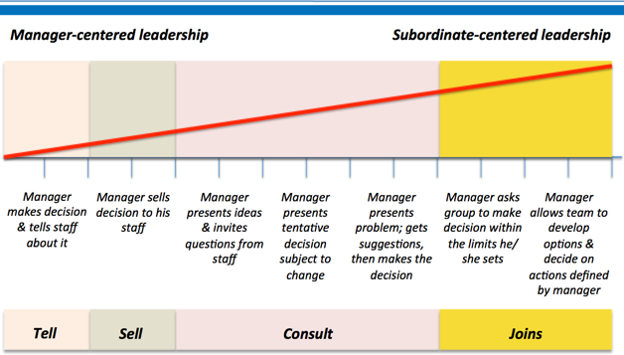
Laissez-Faire
Autocratic
Democratic
The researcher has chosen the three most opposing leadership styles to assess and compare in order to be able to analyse the effect of leadership styles on the workforce. The researcher will also be using the Tannenbaum and Schmidt Continuum of Leadership model in order to further analyse the effect of these three opposing leadership styles on the workforce. The autocratic, democratic, and laissez-faire styles of leading are three very opposite ones. The autocratic leadership style requires much more of the leader making the decisions and setting out plans for work to their workforce. Democratic leadership involves much more give and take between the leader and the employee. The workforce under a democratic leader is usually much more motivated. The laissez-faire leader is much more laid back and hands-off. They set time limits around operations and they tend to ask their workforce to come up with decisions for them in this specifically set time frame.
- Autocratic Leaders: As mentioned, autocratic leaders tend to make decisions with very little to no input from their employees. They are usually more confident leaders who are more sure about the decision making responsibility. Researchers have indicated that autocratic leaders are less likely to make space for creativity in the workforce (N, S and N, 2020). An autocratic leader is one that has full control over the workforce around them (N, S and N, 2020). Autocratic leaders also tend to believe that they have the authority to treat their workforce in whichever manner they please (N, S and N, 2020). As mentioned, these qualities come in handy when operations within the workforce require immediate and quick decision making. Research also shows that this type of leadership style is useful for a short period of time (N, S and N, 2020). If used for a long period of time, research indicates that autocratic leadership might hinder productivity. In summary, the autocratic leadership style has both positive and negative effects to it. The positive is that this leadership style, as mentioned, is useful at times when immediate and quick actions is required. The negative aspect to this leadership style is that it can be very overwhelming on the employee. The employee, under this leadership style, is starved of creativity. Motivation and morale are often low. It can get quite repetitive for the employees and managers since there is no creativity or motivation and it is a very one-sided way of operating where all the decisions fall under the hands of the leader.
- Democratic Leaders: The democratic leadership style differs immensely from the autocratic leadership style. The democratic leadership style encourages creativity and motivation on the workforce (N, S and N, 2020). Democratic leaders usually invite and encourage input on the decision-making process. Responsibility is usually shared under this leadership style (N, S and N, 2020). This leadership style is a much more hands on process for everyone in the workforce. Employees also tend to feel more included under a democratic leader (N, S and N, 2020). The workforce atmosphere is also much less tense than that of an autocratic leader. This leadership style focuses on the utilisation of the skills, experience, and ideas of the members of the workforce. However, as inclusive and motivating this leadership style is, the final decision is always in the hands of the leader. Additionally, prior and during the leader’s final decision-making process they will always be taking input from the staff members around them. The democratic leadership style is usually useful for both short and long term and is usually used in varying industries. This leadership style also improves the performance of the workforce.
- Laissez-Faire Leaders: Laissez-faire leaders are usually much more laid back than other types of leadership styles. This leadership style is based on trust above all else (Indeed.com ,2020). Employees who are comfortable working under a laissez-faire leader are usually much more creative and like their independence. The laissez-faire leadership style does not require a lot of definitive outlined work (Indeed.com ,2020). This leadership style allows the employee to exercise and improve on their own creativity (Indeed.com ,2020). The leadership style also allows the employees to make use of their resourcefulness in order to complete their organizational goals (Indeed.com ,2020). There are some disadvantages to this leadership style on the workforce. For instance, this leadership style is not suitable for newcomers (Indeed.com ,2020). Up and coming professionals who might need some guidance and authority might find this leadership style to be stressful to operate under. There is also a certain amount of lack of structure within this leadership style. In order to successfully carry out a laissez-faire leader’s role one must find the proper balance between establishing a rigid structure as well as no structure at all. Lack of support is another disadvantage to this leadership style. Lack of support can make employees feel unsupported during stressful times. This might lower morale and motivation. In order to avoid such issues, leaders must allow their staff to work freely and creatively but they also need to assure them that it is appropriate to reach out for help.

  - Primary Research Findings
In order to further assess the effect of Leadership on the workforce, the researcher conducted 7 interviews with professionals from varying industries. The interviews listed below will cover and analyse the findings from the interviews.
- Interview 1: The first interviewee is a female who worked at a customer service sector of an organisation. The interviewee worked at this organisation for 6 years. The interviewees leader was also a female. The interviewee states that her leader was effective but lacked compassion. She was motivational and encouraging. She was also time efficient and had good organisational skills. The interviewee would describe her time working under her leader as very beneficial and states that her leader was very influential. The leader taught the interviewee the proper organisational skills she needs to carry out her job. The interviewee states that her leader was very task oriented. However, the interviewee also indicates that her leader was still very motivational and cared for her workforce’s well-being and overall improvement. The leader, according to the interviewee, at times, would take on more of a coach’s role. The leader would teach her staff by showing them first-hand how the work is done. Based on the conducted interview, it is safe to say that the leader in this case took on a more democratic leader role with a hint of a coaching leader. The leader seems to have been very efficient at her work and cared about the growth of her workforce.
- Interview 2: The second interviewee is a female who works at an import and export trading organisation. The interviewees leader is a male. The interviewee has worked at this company for over 10 years. The interviewee states that the job was exciting at the beginning. However, the interviewee also indicates that, after getting settled into her role, the leader’s attitude started to change in a negative way. The interviewee also expressed that the leader created a negative workforce atmosphere. The leader had started to show signs of unnecessary sarcastic attitude towards the employees as well as prying into the employee’s personal lives. The interviewee continues to state that the leader’s impact on her was negative and that she felt demotivated working under his authority. The interview states that there was no reward when it came to good performance. She states that whenever she’d feel motivated to do her best, she would later feel demotivated because, as she states, she would find “nothing in return”. The interviewee believes that a true leader is one who cares about their workforce’s wellbeing and is someone the employee would be proud to work for. When asked whether she feels her leader was more democratic or autocratic, the interviewee stated that her leader would be a mixture of both. The researcher believes that the leader is in fact a mixture of both leadership styles. However, based on the outcome of this interview, the leader seems to be leaning more towards the autocratic side of the spectrum. The researcher came up with this conclusion because the leader in this case is showing signs of a leader who operates in an autocratic manner. As, mentioned, autocratic leaders are much more task-oriented and leave very little room for creativity and the workforce under their leadership is usually demotivated.
- Interview 3: The third interviewee is a female who works in the hospital field as an assistant. The interviewees leader is male, and she has worked at this company for over 3 years. The interviewee states that the leader was good and efficient. However, the interviewee also states that the leader was very moody. She continues to indicate that the leader would become very difficult to work for when he gets in a bad mood. The interviewee also indicates that the leader had trust issues which heavily impacted her motivation and willingness to work. She states that the leader would always doubt and question his employees. She continues to explain how the leader has a negative effect on her work. The interviewee believes that an efficient leader is one who is easy going and in control of his temper and emotions. Based on the findings from this interview, what can be concluded is that the leader does not fall under a specific leadership style. However, when choosing the leadership style that is most similar to his, the autocratic leader would be the one.
- Interview 4: The fourth interviewee is a male who works in the customer service department of a large restaurant chain. His leader is a male. The interviewee has worked at this company for 7 years. According to the interviewee, the leader was efficient. He also states that his leader had a positive impact on the interviewee. The interviewee also states that the leader was motivating and gave fair promotions. The leader took time to train the employees and help them improve and made sure they acquired the adequate skills required to operate in such industries. What can be concluded from the findings of the fourth interview is that the leader seems to be very fair and encouraging. They also seem to be very hands on when it comes to both their work and their employees work as well. This leader displays signs of a more democratic leader. He is fair and just and cares about the improvement and motivation of his workforce.
- Interview 5: The fifth interviewee is a female who worked as a manager in a well-known restaurant chain. Her leader was a female. The interviewee worked at this organisation for over 5 years. The interviewee states that her leader was a very compassionate leader who was also very direct and had a good work balance. According to the interviewee, the leader was motivational and encouraged the improvement of her staff. The interviewee indicates that the leader was very helpful and generous with her knowledge. The leader cared about her teams’ comfort and was social with the staff. The interviewee stresses expressively on her leader’s communication skills. She states that her leader was very work and time efficient due to her impeccable communication skills. What can be concluded from the findings of this interview is that the leader is very efficient with their time and the way they operate. The leader seems very motivational and generous with her knowledge. This leader’s leadership style leans more towards the democratic leader’s style.

  - Real World Comparison
Inefficient leadership can lead companies into turmoil and garner them a lot of negative attention from the public and the press. An example of inefficient leadership is Uber. Uber is a company that specializes in offering quick transport solutions to their customers. Travis Kalanick was the CEO of Uber back in 2017. Frances X. Frei and Anne Morris, Contributors at the Harvard Business review have stated that Uber’s success “seemed to have come at the price of basic decency”. For example, in 2017, when the taxi drivers in New York City went on strike to protest the travel ban set by President Donald Trump, Uber seemed it have benefitted from the situation by using tactics to profit from it (Anne Morriss, 2020). There have also been numerous reports detailing the harassment and discrimination of Susan Fowler, an engineer at Uber. Not long after, a leaked video that went viral showing then CEO, Travis Kalanick, interacting with an Uber driver and appearing to be dismissive of the hardships and pain of earning a living in a post-uber world (Anne Morriss, 2020). Kalanick became viewed as a “cold-blooded operator that would do almost anything to win” (Anne Morriss, 2020). This case shows that inefficient leadership can cause an organisation a lot. It can ruin an organizations reputation and affect the credibility of the leader.

Chapter 4: Reflective Statement
  - Planning
Leadership is a topic that is of great importance to the researcher. The researcher chose this topic because they believe that the workforce is greatly impacted, either positively or negatively, depending on the leader carrying it. The research on leadership is also very important to the researcher as they will soon be applying for jobs and joining the workforce and it would be greatly beneficial to learn about the leadership impact on the employees. During the beginning stages of planning, the researcher started organizing how they would carry out this capstone. The researcher started by figuring out how they would research and what type of research they would use. The researcher ended up using both research methods. Both research methods were chosen because the researcher felt that they could make use of both methods within their topic and would also have the chance to get an outsider’s point of view by doing so. The researcher then proceeded to plan a schedule for their work. The schedule consisted of time frames relating to when each aspect of the work is expected to be done. After finalizing a plan and a schedule the researcher proceeded with the research and started plans for the interviews.

  - Research
The research aspect of this capstone was particularly challenging for the researcher. The researcher started by looking through online articles and noting down what other journalists and specialists have said on leadership. The researcher then went on to assess and identify the different types of leadership styles. While doing so, the researcher realized that there are numerous amounts of leadership styles. The researcher went on to choose the seven leadership styles they thought were the most suitable ones. The researcher then started conducting the interviews. The interviews took the researcher 4 weeks to finalize with an extra 2 weeks prior to plan the interview questions. The researcher interviewed a total of 13 professionals and chose the ones that are the most interesting and detailed to assess and include in the capstone. It was challenging on the researcher to pick the best interviews to use. The researcher came up with this decision by filtering out the interviews that were similar and choosing the most interesting ones. After finalizing the interviews, the researcher began the process of writing and researching. The researcher also started to use the data they collected from the interviews and comparing them to online articles and academic journals.

  - Reflective Statement Summary
The researcher felt that this experience was very beneficial. They learned a lot about research skills and organisation skills. They also learned a lot about communication. During this process the researcher was always asking questions in order to be as organised and as prepared as they can. This experience was also very challenging. The interviews were probably the most challenging factor of this experience. The interviews took a lot of time to finalize and a lot of rescheduling as well. However, the experience itself was very rewarding, motivating, and very insightful. The researcher learned a lot from the challenges and adversities they faced during the research and writing process of this capstone. If the researcher was to conduct a project like this again, they would make sure to pilot test in order to ensure the best primary research outcome.

Chapter 5: Conclusion and Recommendations
  - Conclusion
Leadership is an important role that needs to be maintained and harnessed. A leader needs to be attentive and committed at all times while simultaneously providing encouragement and motivation to their staff. Doing so will ensure the leader a much more harmonious workflow and a clearer and positive workforce atmosphere. The findings from the primary and secondary research methods have shown that leadership cannot be done in a centralized manner. There needs to be a flow of communication stemming from the leader and making its way to the managers and the staff members. As discussed, communication is key when it comes to leadership. A leader who lacks the adequate communication skills will almost always find challenges in their work. Communication makes every operation happening in the workforce much clearer on everyone including the leader. Motivation is also very important. Staff needs to stay motivated in order to produce quality work. A demotivated staff member will lose the drive to work and subsequently, produce low quality work. An efficient leader must also allow space for creativity within his workforce.
Creativity allows the. Staff members to venture out of their comfort zones and start exploring with their work. Creativity can also cause failure, which is necessary. Failure is crucial to an employee’s journey in an organisation. Members of the workforce will learn from their failures and make sure such situations never occur again. Failure helps employees to grow in every aspect of the work. To conclude, the researcher’s objectives have been met. The identification of a range of leadership styles have been assessed. The researcher has analysed the effects the different leadership styles have on the workforce. The researcher has also determined where the varying leadership styles fit best with the different business sectors.

  - Recommendations
The recommendations made by the researcher are:
- Allocate different requirements for specific leadership roles. For instance, if an industry requires a more laid back and hands-off leader, they would set requirements for eligibility to fulfil the role where the leader taking on the role would have to be a laissez-faire leader. This would allow for less time for the leader to acclimate to the organisations culture and more time to get to work as the leader would already be familiar with the workforce atmosphere.
- Give more leadership roles to existing members of the company rather than bringing in someone entirely new. This would ensure that the leader taking on the role is familiar with the company’s values and the people operating it.
- Provide training or coaching to new leaders on how to communicate, motivate, encourage, and allow creativity. This process can happen in-house, or the company could send their potential leaders to outside workshops.
- Leaders can join leadership forums and become a part of a community of best practice. This would allow the leader to see how others operate and achieve their goals as well as face their challenges.

  - Further Research
For further research, the main finding of this research could be taken into consideration. For instance, the findings on motivation, communication, etc... could be designed into further questions for further study. This could be done by providing questionnaires to employees and leaders in order to obtain a larger range of data with the use of mostly close-ended questions, such as scales, and some open-ended questions as well. Further secondary data sources can be achieved through consultancy reports, company reports, and other case studies.

6 Appendix
6.1 References
Main. 2020. 5 Challenges To Leadership Effectiveness. [online] Available at: <https://www.td.org/insights/5-challenges-to-leadership-effectiveness> [Accessed 20 March 2020].

HRZone. 2020. 6 Most Common Leadership Challenges At Workplace. [online] Available at: <https://www.hrzone.com/community/blogs/rohia-munavar/6-most-common-leadership-challenges-at-workplace> [Accessed 20 March 2020].

Bawany, P., 2020. The Impact Of Leadership & Culture On Productivity - Executive Development. [online] Executive Development. Available at: <https://www.executivedevelopment.com/the-impact-of-leadership-culture-on-productivity/> [Accessed 20 March 2020].

Becker, B., 2020. The 8 Most Common Leadership Styles & How To Find Your Own. [online] Blog.hubspot.com. Available at: <https://blog.hubspot.com/marketing/leadership-styles> [Accessed 20 March 2020].

Bridges, J. and Bridges, J., 2020. Common Leadership Challenges - Projectmanager.Com. [online] ProjectManager.com. Available at: <https://www.projectmanager.com/training/leadership-challenges> [Accessed 20 March 2020].

Goodman, P., 2020. 10 Common Leadership Styles. [online] ToughNickel. Available at: <https://toughnickel.com/business/Ten-Common-Leadership-Styles> [Accessed 20 March 2020].

Smallbusiness.chron.com. 2020. How Does Leadership Style Influence Organizational Productivity?. [online] Available at: <https://smallbusiness.chron.com/leadership-style-influence-organizational-productivity-11643.html> [Accessed 20 March 2020].

M. Mensah, Y. and Qi, Y., 2020. [online] Available at: <https://www.researchgate.net/profile/Yaw_Mensah/publication/309709960_Preferred_Leadership_Styles_Culture_and_Government_Fiscal_Transparency_An_International_Analysis/links/582729cf08ae5c0137edcf7c/Preferred-Leadership-Styles-Culture-and-Government-Fiscal-Transparency-An-International-Analysis.pdf> [Accessed 20 March 2020].

CEO Coaching International. 2020. The Seven Biggest Problems With Leadership Today. [online] Available at: <https://ceocoachinginternational.com/problems-with-leadership> [Accessed 20 March 2020].

Training, L., Us, A. and Us, C., 2020. How Leadership Affects Productivity & Why Happiness Matters (PLUS 5 Behaviors That Inspire & The “Bad Boss” Types To Avoid).
[online] Inspiring Leadership Now. Available at: <https://www.inspiringleadershipnow.com/how-leadership-affects-productivity/> [Accessed 20 March 2020].

Anne Morriss, F., 2020. Everything Starts With Trust. [online] Harvard Business Review. Available at: <https://hbr.org/2020/05/begin-with-trust> [Accessed 7 May 2020].

Day, D., 2020. Business Results And Effective Leadership – “Effective Leaders Outperform Ineffective Leaders Every Time.” - The Leadership Circle. [online] The Leadership Circle. Available at: <https://leadershipcircle.com/en/business-results-and-effective-leadership-effective-leaders-outperform-ineffective-leaders-every-time/> [Accessed 7 May 2020].

Gaille, B., 2020. 19 Advantages And Disadvantages Of Democratic Leadership Style. [online] BrandonGaille.com. Available at: <https://brandongaille.com/19-advantages-and-disadvantages-of-democratic-leadership-style/> [Accessed 7 May 2020].

Mahaffey, D., 2020. Council Post: How To Demonstrate Successful Leadership In The Workplace. [online] Forbes. Available at: <https://www.forbes.com/sites/forbescoachescouncil/2016/08/12/how-to-demonstrate-successful-leadership-in-the-workplace/#77d1d5907a88> [Accessed 7 May 2020].

Martinuzzi, B., 2020. The 7 Most Common Leadership Styles (And How To Find Your Own). [online] Business Trends and Insights. Available at: <https://www.americanexpress.com/en-us/business/trends-and-insights/articles/the-7-most-common-leadership-styles-and-how-to-find-your-own/> [Accessed 7 May 2020].

N, I., S, A. and N, H., 2020. [online] Hilarispublisher.com. Available at: <https://www.hilarispublisher.com/open-access/effect-of-leadership-style-on-employee-performance-2223-5833-1000146.pdf> [Accessed 7 May 2020].

Statistics How To. 2020. Purposive Sampling (Deliberate Sampling) - Statistics How To. [online] Available at: <https://www.statisticshowto.com/purposive-sampling/> [Accessed 7 May 2020].

Vernon, J., 2020. 6 Ways To Improve Your Leadership Skills For Research. [online] Sigmaxi.org. Available at: <https://www.sigmaxi.org/news/keyed-in/post/keyed-in/2019/07/16/6-ways-to-improve-your-leadership-skills-for-research> [Accessed 7 May 2020].

Indeed.com. 2020. Laissez-Faire Leadership: Definition, Tips And Examples | Indeed.Com. [online] Available at: <https://www.indeed.com/career-advice/career-development/laissez-faire-leadership> [Accessed 7 May 2020].

Le Voi, M. (2006) Legal and Moral Constraints on Researchers, In Seale, C. (2004) Social Research Methods, Routledge, UK.

Kvale, S. (1996) Interviews: An introduction to qualitative research interviewing, SAGE, London

Gillham, B. (2007) Developing a Questionnaire, 2nd Edition, Continuum International Publishing Group, London

Williams, C. (2015) Doing International Research: Global and Local Methods, SAGE, London

Somekh, B., & Lewin, C. (2005) Research methods in the social sciences, SAGE publications, London

6.2 Reflective Summary
Week 15

Questions  Please not: You don’t need to reflct on all of the sub questions below. | Reflections
Primary researchers  In the first half of the seminar we looked at final checks for your questions for primary data. Do you think you have enough questions/probing questions/do the questions link/address the research objectives? Are you ready to distribute the questions? If not, why not?  In the first half of the seminar if you had already completed your questions do they meet the objectives of your research/are any patterns/themes emerging/how is access to participants progressing?  Secondary researchers  Which sources have you accessed? Have the information/sources been linked to address the objectives? | Yes, I have enough questions. I am almost ready to distribute these questions. I will be distributing these questions after gathering 3-4 more questions.  Yes, they do meet the objectives. Access to participants is good. I was able to gather 10 participants.  Academic Journals and online articles.  Sources have been linked to the objective
In the second half of the seminar we looked at the contents and structure of Executive Summary and Chapter 1, did the samples help? Did it build your confidence? Did you try and attempt to structure your own subheadings? How did you find this task? | Yes the samples did help. I have tried to structure my own subheadings. The task was helpful.
Overall thoughts (optional- if needed):

6.3 Iterations
Week 14
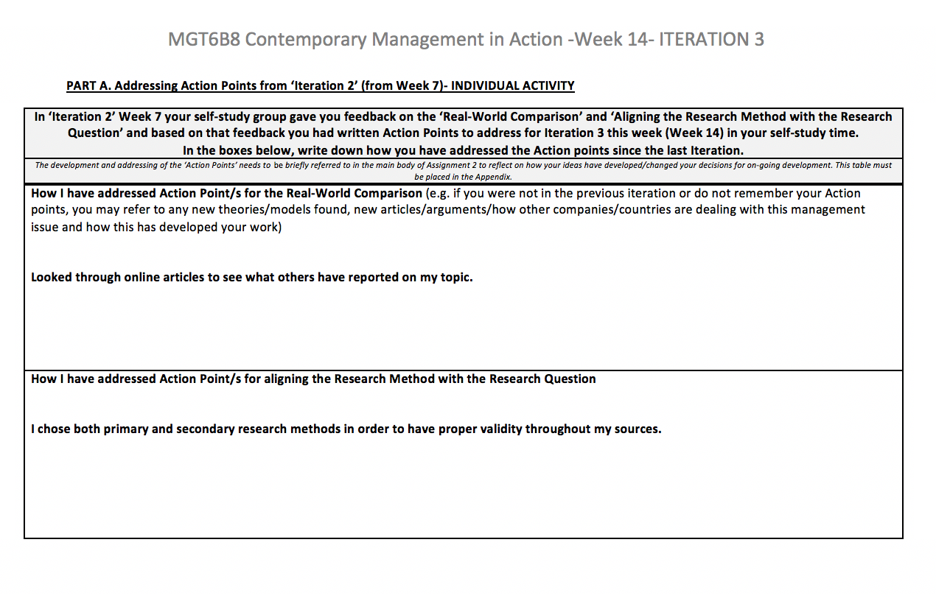

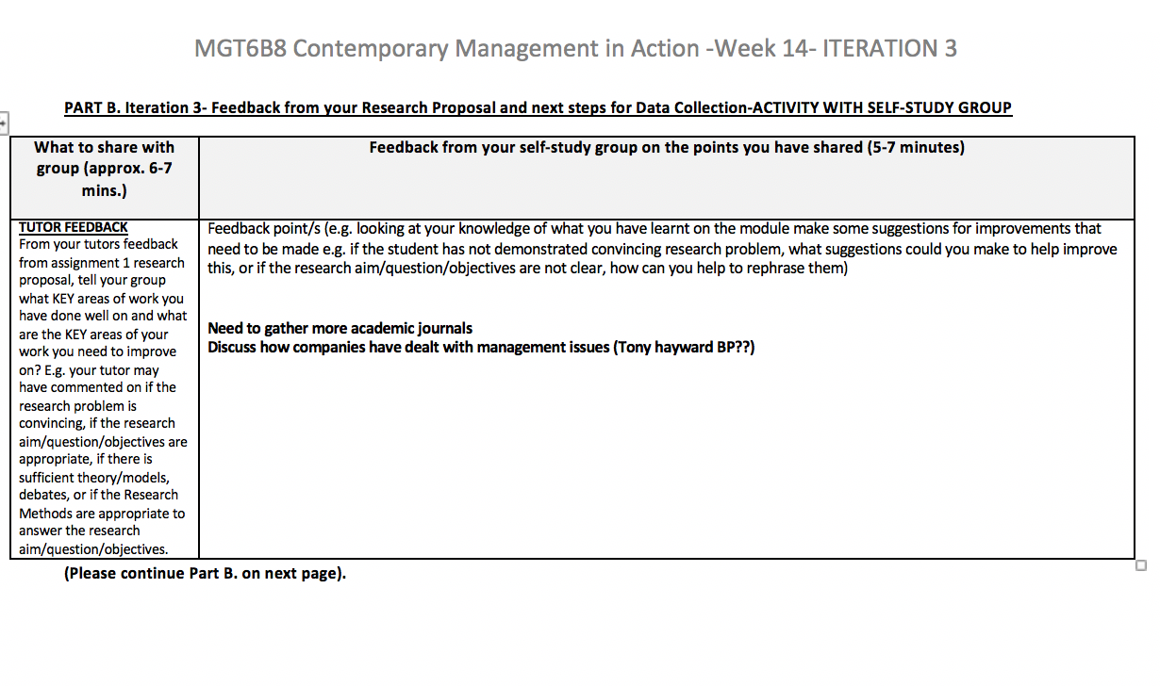
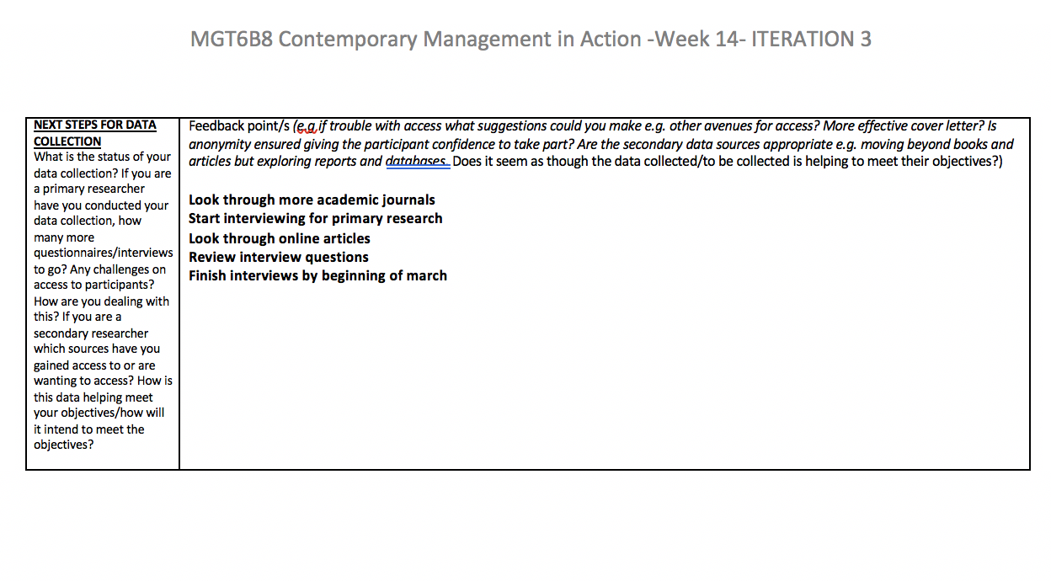

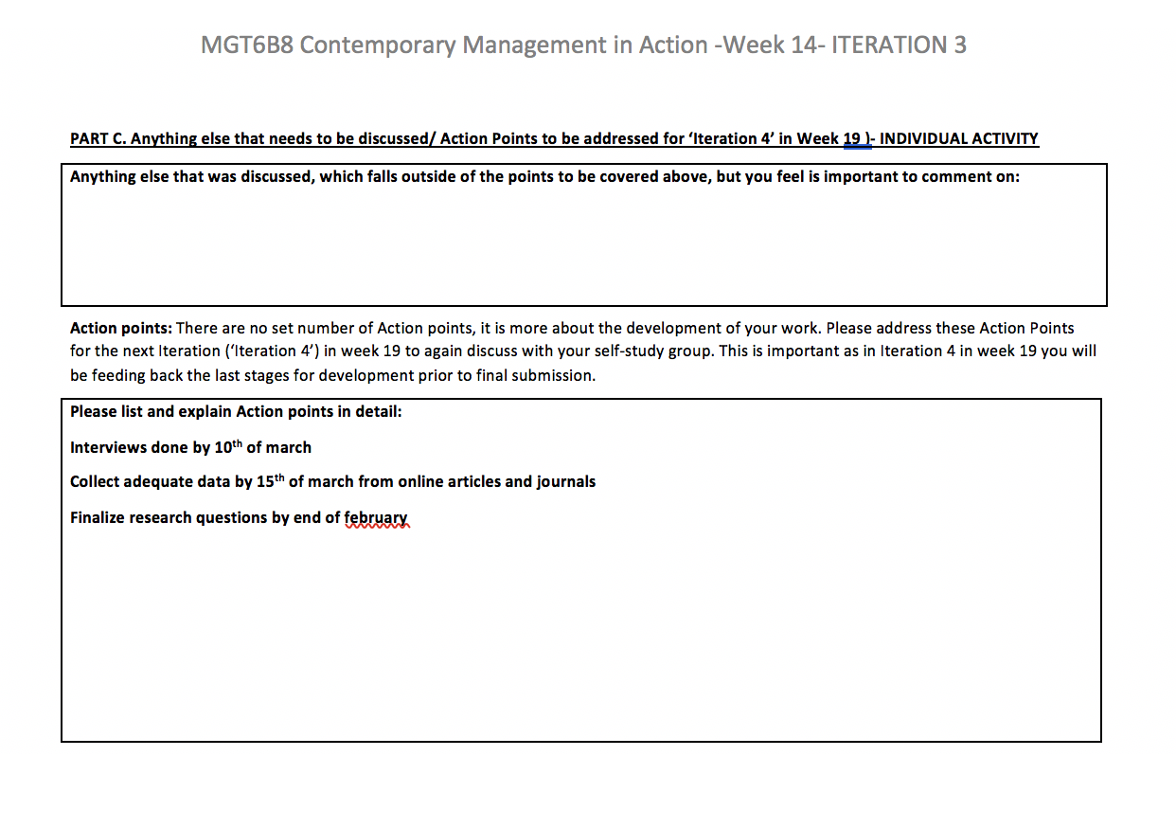

Week 19

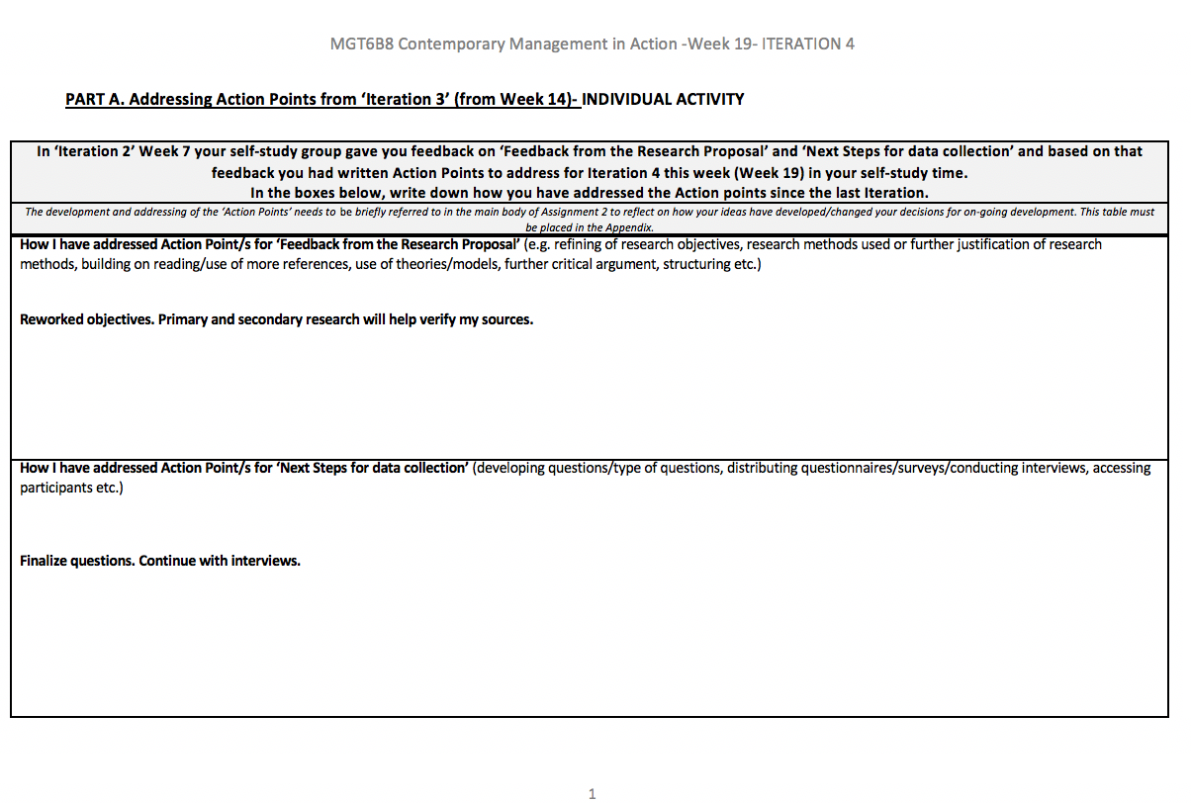

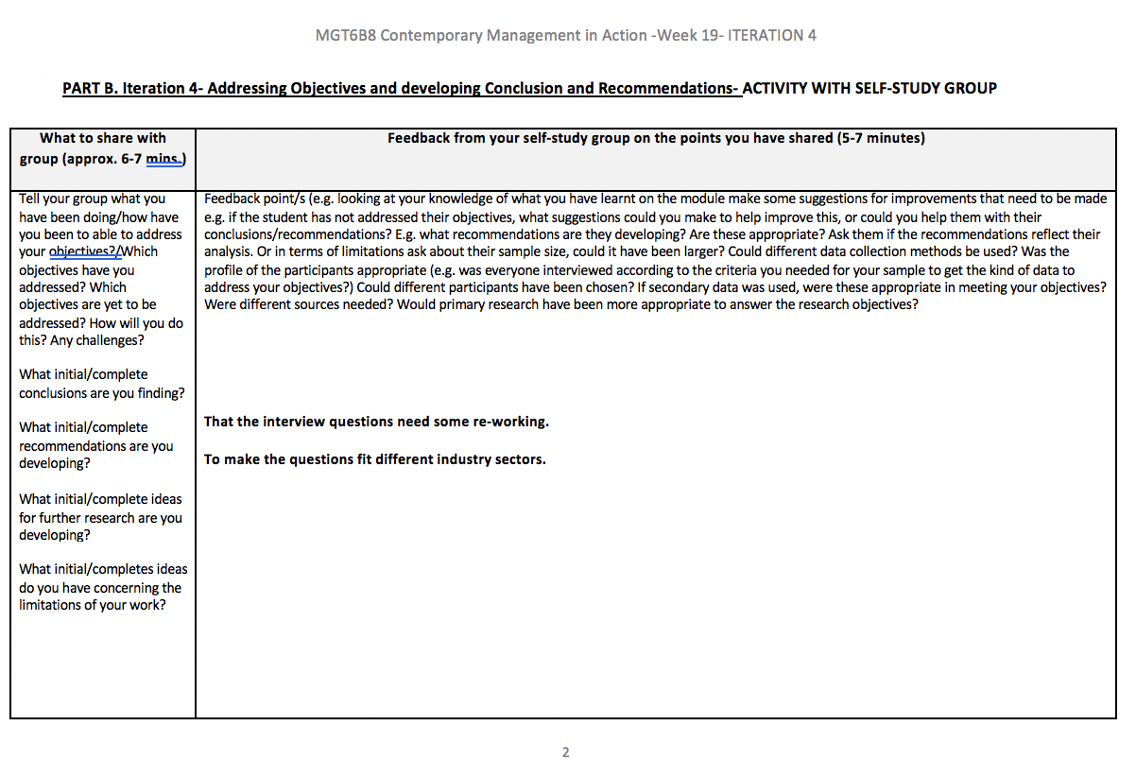

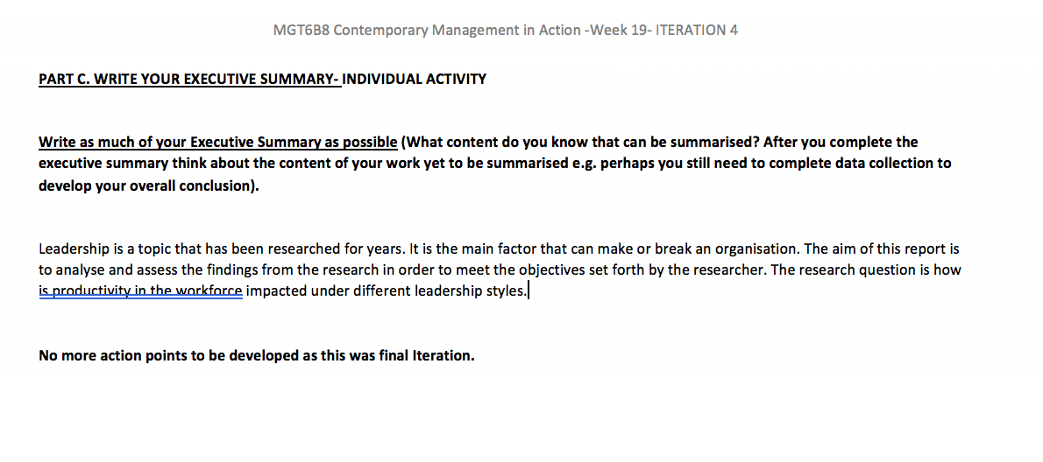

6.4 Research Ethics Form

Application for Ethical Approval of Research

This application form is to be used for all research projects undertaken by Regent’s University staff of students where the proposed research involves human participants or their personal data. Approval must be given before the research commences.

Before completing this form, it is essential that you read the University’s Research Ethics Policy which can be found here:

https://connect.regents.ac.uk/facultiesandschools/research/Pages/ResearchEthics.aspx

You should email the application to the relevant Faculty or Institute Research Ethics Officer. The proposal will then be forwarded to a Research Ethics Review Panel comprising three members from a pool of academic staff with the appropriate knowledge and experience to review the proposal, either confirming approval, requesting further information or – where the panel has serious concerns about the ethics of the proposal – withholding approval. Decisions made by the panel are recorded and logged for monitoring purposes. You will be notified of the outcome of the Research Ethics Review Panel by its Chair or Secretary.

Please select:
□ Staff Research Project Application
□ PhD Student Research Project Application
□ Masters Dissertation Research Project Application
- Individual UG or PG Research Project Application
□ Template Research Project Application for taught module project briefs (please discuss with your Faculty/Institute Research Leader before submitting)

J:\RC Registry\Policy

1. THE RESEARCH PROJECT AND THE RESEARCHERS |  | For Research Ethics Review Panel Use only:  panel comment, concerns, queries
Name and position of principal researcher | Sam Sadek (Student Researcher)
Email address | S00907812@regents.ac.uk
Telephone
Faculty or Institute | BAM
For Academic Staff only:

Line Manager/Faculty or Institute Research leader name, position, email and telephone
For PhD/Master’s student dissertations only:

Project Supervisor: name, position, email and telephone
For UG student projects/ dissertations only:  Module tutor: name, position, email | Vicky Ghassemi, Lecturer, ghassemiy@regents.ac.uk
Proposed title of research project | “How Would Productivity in the Workforce be Impacted Under Different Leadership Styles (Autocratic & Democratic)”
Intended start data for research | 2nd December 2019
Intended end date for research | 1st of May 2020
List of other staff or students to be involved in conducting the research | N/A
Funding sought/granted: source and amount  (if applicable) | N/A
Details of proposed project including aims, methodology and plans for dissemination  (max 500 words) | This report aims to analyze the different effects the mentioned types of leaders have on their workforce. Furthermore, this report aims to differentiate between the two emphasized types of leaderships in order to determine which one holds the best productivity rate within their workforce. The topic to be discussed is “How would productivity in the workforce be impacted under different leadership styles” focusing on autocratic and democratic leaders. Most scholars and practitioners would argue that in an autocratic environment the leader of the workforce will direct their subordinates on what is to be done and how it should be done, making the leader the centralized decision maker in the overall labor pool (S, 2019). On the other hand, it has been discussed that a democratic leader is one that grants their subordinates a chance to be a part of any decision-making process (S, 2019). This gives the subordinates a more inclusive and arguably a more pivotal role in the workforce environment. The objectives of this report are to be able to find which type of leader has the most effect on the productivity of the workforce and how different employees respond to their leaders type of governance. After gathering the appropriate research and insights I will then be able to differentiate between the types of leaders and distinguish which one works best in an array of varying sectors and industries. The Interviews to be conducted have been carefully curated by myself in a way that will allow me to analyse the varying authoritative effects on the workforce. I will be interviewing people from different backgrounds and with different work ethics and see how they have been affected by their current or past leaders. There will be interviews conducted with executives who have worked in high corporate businesses like the oil industry, as well as interviews with employees of the retail industry and many different industries varying between the former and the latter. These interviews will help me meet my objectives of being able to analyse the different effects these leadership styles have on their workforce in their respective industries. Having an array of different industries will help me further analyse and compare how the productivity rate varies between each sector. I also intend to interview people who have worked under the governance of different genders. This will allow me to analyse and compare the different effects each gender has on their workforce and then meet my objective of being able to differentiate between the two and assess the level of effectiveness present in both genders. This report will also allow me to further analyse different types of leader and see whether similar leadership styles lead a similar productivity rate in their workforce.
2. SAFETY OF RESEARCHERS

Do those named above require specific training to conduct the proposed research safely and in accordance with the Research Ethics Policy? | NO
Are researchers likely to go to any areas or contexts where their safety might be compromised? | NO
Could researchers have any conflicts of interest? | NO
3. SAFETY OF PARTICIPANTS

Does the research involve any physically invasive or potentially physically harmful procedures? | NO
Could the research induce any stress or psychological discomfort to participants? | NO
Will participants be involved potentially without their consent? (e.g. through covert observation) | NO, I will seek permission before I conduct research.
Will the research involve participants from vulnerable groups (children, adults with special needs, the elderly, the disabled, prisoners, hospital patients, people under psychological treatment) | NO
Do the researchers named above need to be cleared through any disclosure procedures? (e.g. for working with children) | NO
Will the research involve participants who are in a professional or client relationship with the researcher(s)? (e.g. their students or their therapy or business clients) | NO
Could this research affect adversely participants in any other way? | NO
4. INFORMATION AND CONSENT

How many participants will be recruited? | 25 more or less
What criteria will be used in selecting participants? | Level of employment
How will the sample be recruited? | Primary and Secondary Research (I will be setting up face to face interviews to those who I am able to meet with and phone the people who can’t meet. For my secondary research I will be gathering information online as well as from the library, if necessary).
What information will be given to participants prior to their consent? | A list of question set forth by me. The questions will relate to the topic I have chosen and will relate to their personal experience working under the different types of leaders.
How will participant consent be requested and recorded? | Through email or printed for signature
What additional processed will be used to gain consent where participants’ first language is not English?
Confirm that participants will be informed they may withdraw consent at any time. | YES
Are participants offered any benefits from their involvement? (financial or other) | NO
Are participants offered the chance to see the resulting research? | YES
5. DATA PROTECTION

Does the research include recording (audio or video) of participants? | YES
How will the confidentiality of recorded data be ensured? | Will be keeping participants anonymous
How and where will the data be stored? | Hard copies or locked in computer + password protected
Who will have access to the data? | Me and my supervisor Vicky
For how long will the data be stored? | At least up to 1 year
How will the data be disposed of? | Shredded or Deleted from computer system
What, if any, steps have been taken to anonymize data before dissemination? | Yes, I will anonymize data including companies and participants.
Will any information from the data be passed on to third parties such as companies or organizations? | NO
6. ETHICAL APPROVAL REQUIRED BY OTHER BODIES

Is the research proposal scrutinized by any other external body in respect of its ethical approval? | N/A
7. OTHER ISSUES OR INFORMATION

Please list here any ethical issues that have been addressed but are not covered by the questions above | NO
Please write here any other information you think the Research Ethics Approval Panel should know to help them to come to a decision on this application | NO
8. DECLARATION

I confirm I have answered all the relevant questions on this application form.  I confirm I have read and understood the requirements of the Research Ethics Policy  I confirm I have attached a research proposal (where available) and any Participant Information materials to the email | YES
Signed | Sam Sadek
Date | 22/11/2019
9. LINE MANAGER / RESEARCH LEADER or SUPERVISOR DECLARATION

I confirm the applicant has answered all the relevant questions on this application form.

I confirm to the best of my knowledge that the proposal meets the requirements of the Research Ethics Policy

I confirm that any applicable additional requirement by validating, accrediting bodies and/or collaborative organizations have been met

Signed by Line Manager/Research Leader/Supervisor
Date

For Research Ethics Review Panel use only:

Research Ethics Review Panel (Decision and Rationale)
Name of Chair of RERP
Name of second member of RERP
Name of third member of RERP (from different Faculty/Institute)
Tick which applies below
APPROVED | FURTHER INFORMATION REQUIRED |  | NOT APPROVED
Any areas of good practice identified in the application
(whether or not it was successful)

a) In case of approved applications:

Summary of discussions of any of the points recorded in the above sections, including any concerns and questions that have been considered to the satisfaction of the panel.
b) In case of applications where panel requires further information from applicant:

Summary of discussions of any of the points recorded in the above sections, including any concerns and questions that remain to be answered to the satisfaction of the panel.

The Chair of Secretary of the panel should communicate the required information directly to the applicant via letter or email.
c) In case of applications not approved:

Detailed description of the reasons for denial of ethical approval including an evaluation as to whether a revised application might be potentially viable.
Signed by Chair of Research Ethics Review Panel
Date

6.5 Interview Questions & Transcribed Interview

- Interview Questions:
Was/Is your leader a male or a female?

How long have you been working for the company?

How would you describe your leader’s leadership skills? Would you say your leader was more autocratic or democratic?

How would you describe your experience working under this leader’s authority?
How would you describe the workplace atmosphere this leader created?

What effect does this leaders leadership style have on the workforce?

Which leadership style do u feel best suits the industry you work or worked in?

- Transcribed Interview:
Female

5 Years

Compassionate leader who was also direct and had good work balance. Motivational and gave guidance. Cared for improvement of staff.

Leader gave interviewee confidence. Was very helpful and generous with her knowledge.

Leader cared about staff’s comfort and was social with the staff while also giving them guidance

The leader was a friend to the workforce who also provided them with a lot of guidance

Social and easy going, honest, motivating, and enthusiastic. All the qualities the interviewees leader attains.

